  - Annual Report Sept 2019- Aug 2020
  - Muscular Dystrophy Foundation of South Africa, National Office

Annual Report 2020
  - Muscular Dystrophy Foundation of South Africa, National Office

Contents

1. Mission Statement 2
2. About Us 2
3. National Chairman’s Message 3
4. General Manager’s Report 4
4.1. Governance 4
4.2. Strategic Objectives for 2019/20 4
4.3. Organisational Structure 5
4.4. National Service Delivery Programmes 6
4.4.1. Advocacy, awareness and public education programmes 6
4.4.2. Outreach to Members 7
4.4.3. General Operations and Management 8
4.4.4. Fundraising 9
4.4.5. Support and strengthen the social work support programme at branches 10

Mission Statement

The mission of the Foundation shall be to support people affected by Muscular Dystrophy and Neuromuscular disorders and endeavor to improve the quality of life of its members.

About Us

The Muscular Dystrophy Foundation of South Africa (MDFSA) is a registered non-profit organisation – Reg. No. 004-152 NPO – consisting of a national office and three branches which operate in the nine provinces of South Africa.

The Organisation was founded in 1974 by Mr. and Mrs. Newton Walker of Potchefstroom who, at the time, had a son affected with Duchenne Muscular Dystrophy. The Foundation was established with the aim of reaching out to other parents and families in a similar situation and to support research into this disease with the ultimate goal of finding a cure. The Foundation has been actively involved in carrying out this aim for the past 40 years.

The Foundation’s role within social integration, support services, Muscular Dystrophy awareness programmes and Muscular Dystrophy diagnostic research support is to:

- Enable people to participate in identifying muscular dystrophy needs and to respond appropriately.
- Develop equal caring and coping services for people affected by muscular dystrophy.
- Support affected people with specialised assistive equipment.
- Create public awareness on muscular dystrophy issues and disability.
- Strive for the recognition and protection of the rights of people affected by muscular dystrophy as a disability.
- Support and promote diagnostic research into the causes and treatment of muscular dystrophy.
- Generate funds to support and sustain our work.
- Collaborate and communicate on a national, provincial, international, governmental and non-governmental basis on policy matters relating to all aspects of muscular dystrophy.
- Assist individuals to form self help and support groups.

National Chairman’s Message
It is my privilege as Chairman of the National Executive Council of the Muscular Dystrophy Foundation of South Africa to submit the Annual Report for 2019/20. The report presents achievements recorded during September 2019 to August 2020.

Despite our successes, our country and indeed the globe continued to experience sluggish economic growth that was exacerbated by the COVID 19 pandemic. 2020 has been a year unlike any year before and presented specific challenges to the MDF. This has impacted negatively on our service delivery and fundraising efforts. The past few years have been difficult and financially challenging for the Foundation.

We are grateful to all our donors, funders, and the individuals who, despite the challenging financial climate, continue to generously support us. Your support assisted us in delivering the much-needed services required by our members and their families. We thank you for your continued support.

We always must give acknowledgement and thanks to our biggest financial partner, Crossbow Marketing for the partnership over many years. We would not be able be here today without this partnership and we thank the management and staff for their continual commitment and hard work in securing a constant income for the MDF.

I must commend our dedicated staff and management for pursuing the Foundation’s mandate. I thank you most sincerely for your contribution to the success of the Foundation and the well-being of our incredibly special members. We wish all the branches the best in their continued work to ensure that disabled people benefit from the rights that our Constitution promises them.

The Executive Committee is to be complimented on their engagement during the year. A special word of gratitude to the EXCO for their continued commitment to the betterment of the lives of people affected by muscular dystrophy. I look forward to another year working together to achieve our common goal.

Maatjan Ferreira

General Manager’s Report

I am delighted to present the Annual Report for the Muscular Dystrophy Foundation of South Africa for the period September 2019 to August 2020.

Governance
The Muscular Dystrophy Foundation‘s National Executive Committee was comprised of eight executive members representing each Branch in the following portfolios:

Gauteng: Jan Ferreira (Chairperson), Done Van Eyk (Treasurer) and Hanti Van Eyk.
Western Cape: Win van der Berg (Vice chairperson), Lee Leith (Secretary), Gilda van der Merwe.
KwaZulu Natal: Noel Pillay, Pamela Rapiti and Raj Mahadaw.

Strategic Objectives for 2019/20
Strategic Planning was conducted on 14 March 2020. The strategic objectives for the year were:

- Strategic Objective 1: To create advocacy, awareness and public education programs regarding muscular dystrophy.
- Strategic objective 2: Outreach to members.
- Strategic objective 3: Govern and manage the organisational structure of MDSA.
- Strategic objective 4: Fundraising.
- Strategic objective 5: Support and strengthen the social work support programme at branches.

Organisational Structure

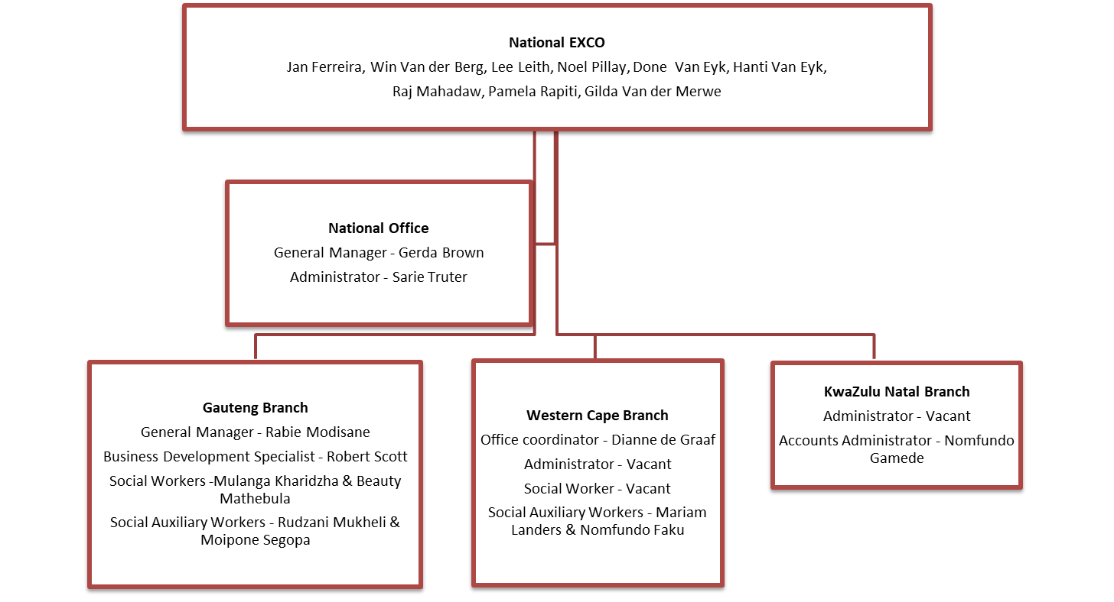

National Service Delivery Programmes

Advocacy, awareness and public education programmes
One of the most important roles of the National Office is informing and educating people about the work of the Foundation, muscular dystrophy and disability in general. In this reporting period MDFSA committed to sharing the message about muscular dystrophy to our communities.

- Radio
The general manager, together with a member diagnosed with Duchenne MD and his mother, was interviewed on “Leefwereld van die Gestremde” on Radio Sonder Grense on 14 June 2020. Another interview was also conducted on “Leef” on Radio Kansel/Pulpit on 13 July 2020. The purpose of the interviews was to raise awareness about muscular dystrophy.

- Television
The Foundation was fortunate enough that eTV agreed to broadcast our advert for the entire 2019. In this reporting period the advert was broadcasted 137 times at a value of R3 626 500.00. Please view our advert on our website (www.mdsa.org.za).

Thank you Foghound Studios for producing an amazing advert about the Muscular Dystrophy Foundation and eTV for donating the valuable broadcast time. We are most grateful for your support.

- Internet
Social media has become the pillar of online awareness programmes. In this reporting period the Foundation posted 132 updates on the MDFSA Facebook page and our following grew from 1329 to 1552 followers. This represents a significant increase in the number of people the Foundation interacts and engages with.

We also launched an Instagram page during April 2020.

Our website is also updated regularly to keep it interesting and current. Please view our website at www.mdsa.org.za.

- Public awareness
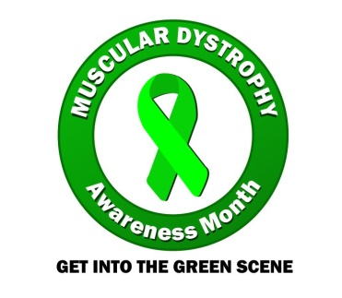
The Foundation celebrated International Muscular Dystrophy Awareness Month during September by running the “Get into the Green Scene” campaign for the second consecutive year. This campaign is our signature social media event to recognize Muscular Dystrophy Awareness Month. The campaign is designed to stand out on social media by combining the campaign’s official colour (green) with an eye-catching image.

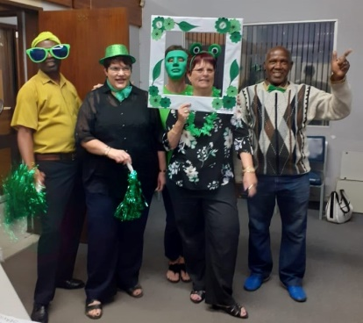
Affected members, their friends and family and various corporates participated in the campaign by posting their “green” photos on the MDFSA Facebook page. This year we were also joined by Cure Duchenne, Kenya; Foundation for Neuromuscular Support, Nigeria; and Magg Biokenetics, Namibia to come together as the African continent in the fight against muscular dystrophy.

A special thanks to all our members, the MDF branches, Wheelchairs on the Run, Newcastle Post Office, CE Mobility, Sound Check SA and Millennium Primary School for taking part in our campaign.

Outreach to Members
The Foundation’s role within social integration, and support services is mainly to provide support to members affected by muscular dystrophy and their families. Support is largely provided by means of psycho-social support, provision of assistive devices and dissemination of information.

- Eastern Cape volunteer office
The Foundation received a donation from FC Robb Charitable Trust towards printing awareness material and a volunteer stipend for the Eastern Cape. On 1 February 2020 a volunteer social worker was appointed (on a 1-year fixed term contract) to provide psychosocial support service to children diagnosed with muscular dystrophy at Vukuhambe School, as well as affected families residing in East London. Currently support is provided to 10 children, and their families, at Vukuhambe School by means of individual counselling, family counselling and life skills group work. Psychosocial support is also provided to three (3) families residing in East London.

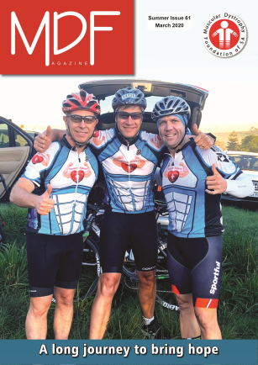
- MDF Magazine
The Foundation distributes an e- magazine to our members, medical professionals, as well as national and inter-national NGOs three times per year. The aim of the magazine is to keep members informed of all activities and research, nationally and internationally.

Thank you to everyone that contributed all the insightful articles to our Magazine, as well as the companies that placed advertisements.

- Coordination of the online adult support group
An online adult support group was established during October 2017. This is a private social group for people who share the bond of Muscular Dystrophy. There are currently 71 members.

- Research
MDFSA was invited by the newly established International Centre for Genomic Medicine in Neuromuscular Disease (ICGNMD) to participate in their research study. The study is led by the University College London and Cambridge University and includes partners from five developing countries, i.e. South Africa, Brazil, India, Zambia and Turkey. The main objectives are to build Neuromuscular Disease cohorts in these countries, identify the genes involved in the disease in each population, and build human capacities in each country and international networks that are sustainable. Reaching these objectives will greatly help to address the treatment of the various Neuromuscular Diseases.

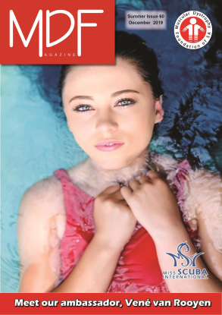
General Operations and Management

- New ambassador for MDFSA
Vene van Rooyen kindly agreed to be the ambassador for the Foundation. She is currently Miss Scuba SA and Miss MWI (Magnificent Woman Icon) SA, as well as the Face of Mpumalanga Tourism. She is passionate about muscular dystrophy as her aunt and grandfather is affected by distal muscular dystrophy.

- Management of member database
As reported previously our member database crashed during December 2017. Since then we have been operating an Excel-based database. We were however in the fortunate position that a Cape Town based company offered to develop a new online database. The development was in its final stages when the COVID 19 pandemic hit South Africa. Due to financial constraints, Find the Gap, however had to de-activate our account.

A special thank you to Andrew Jansen for offering to design a new database for us pro bono.

- Policy development
In this reporting period a great deal of attention was given to ensure sound administration and governance of MDFSA. The nature of our organisation demands that the certain systems and policies and procedures are in place. The following policies have been drafted and implemented:

- Corporate Identity Policy
- Occupational Health and Safety Plan
- Contracts of Employment
- Basic Conditions of Employment
- Performance Management
- COVID 19 workplace policy
- Vehicle policy

Fundraising

- Crossbow Fundraising Campaign
Crossbow Marketing Consultants (PTY) LTD remains our greatest fundraiser. Since 1988 Crossbow has been assisting us to raise funds by designing, manufacturing, marketing and selling various products for and on behalf of MDFSA.

We wish to thank Crossbow for their unwavering support. The income generated by them allows us to work towards the goals of our organisation. We truly see this partnership as essential to our survival.

- National Lotteries Commission (NLC)
An amount of R 914,593.00 has been allocated to the Foundation, inclusive of the National Office and KZN branch. The bulk of the funding was earmarked for a company vehicle for KZN branch but allowance was also made for some operational expenses.

This funding also provided the opportunity to appoint an administrator/fundraiser on a 1 year fixed term contract. A hearty welcome to Sarie Truter in joining our team.

- Donations
We appreciate and give thanks to the individuals and companies for their kind donations. Support of the Muscular Dystrophy Foundation makes it possible to provide a service and support structure to families affected by this crippling and often fatal disease.

- Society Lottery
You may remember that the Foundation reported last year that Rovos Rail generously donated a one-way trip for two people (sharing) in a Deluxe Suite and that we raffled these tickets. A total number of 236 raffle tickets were sold. The draw for the lucky winner was held on 17 December 2019.

Unfortunately, due to the alert levels put in place to manage the COVID-19 pandemic, the train is not operating presently. Rovos Rail graciously made the tickets valid for another year.

A warm thank you once again to Rovos Rail for this fantastic donation.

- Fundraising during COVID 19 alert levels
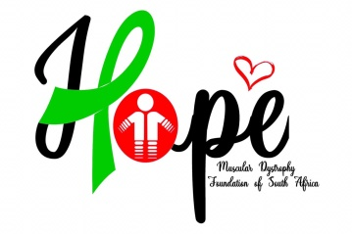
A Fundraising Committee, inclusive of the National Office and all the branches, was established. It was essential that the Foundation re-align existing fundraising strategies as events will not be allowed for some time in the future. We are therefore pressed to continue virtually. In addition, in order to expand our reach and also to minimise fragmentation of efforts, a fundraising strategy was developed for the Foundation.

Campaign | Championed by
Online Quiz | Cape branch
Scavenger Hunt | Cape branch
Move4MD | Gauteng branch
Sunny side up | National office
Birthday donations | All offices
Secure corporate sponsorship | All offices
Coordinate Casual Day activities | All offices

In addition, the National Office also launched an online shop where MDF merchandise may be purchased.

Support and strengthen the social work support programme at branches

- In-service training
A business or organisation should never stagnate and therefore nor should the development of staff, who are the key asset in driving a business forward. Regular staff training is essential in helping ongoing skill development.

The social service professionals participated in a peer-based in-service training programme (via Skype) during this reporting period. The focus of the programme was to increase knowledge about different social work interventions. The following topics were addressed:
- Norms, standards & practice guidelines: Case Work
- Dual diagnosis
- Support services
- Normalization
- Development Plan
- Child-on-child sexual abuse
- Child abandonment
- Support during financial hardship
- Child with special needs
- The role of the social worker in palliative care

The South African Council for Social Service Professionals awarded the training programme 20 CPD points.

- Support services
Psycho-social support services and the provision of assistive devices to affected members are provided by the three branch offices. Detailed information regarding the social work programme is available in the annual reports of the branches.

However, in terms of the Social Service Professions Act (110 of 1978, as amended) all social service professionals are required to work under the supervision of a senior social worker. Due to financial challenges and the subsequent absence of supervisory posts on branch level, it is the role of the National Office to oversee the social work programme and provide guidance to the social service professionals.

Due to the restrictions that COVID19 has placed on us, monthly group supervision sessions were not conducted. In the reporting period 7 group supervision sessions were conducted with the team of social service professionals.

Gerda Brown
General Manager: National Office

