  - Chairman’s Report Sept 2019- Aug 2020
  - Muscular Dystrophy Foundation of South Africa, KZN Branch
(Inclusive of part of the Eastern Cape)

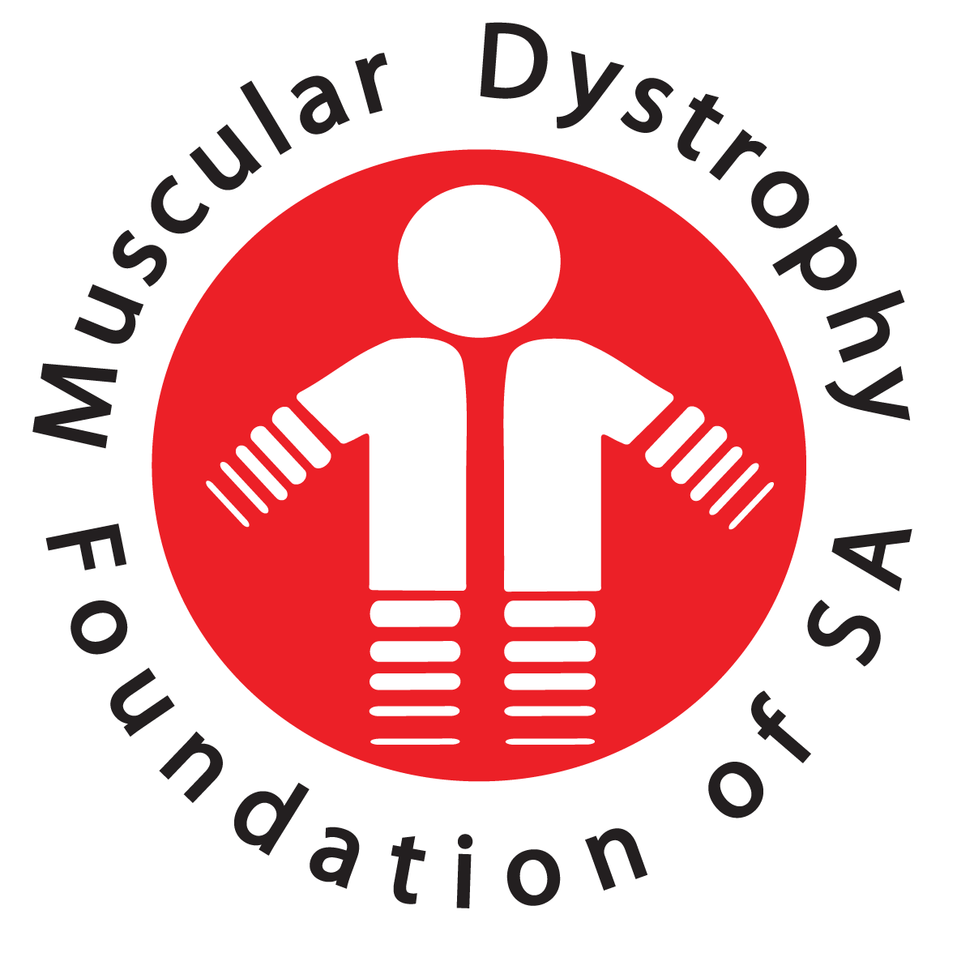

Chairman’s Report 2019
  - Muscular Dystrophy Foundation of South Africa, KZN Branch

Contents

1. DATA BASE 2
2. FUND RAISING 3
3. AWARENESS IN RURAL AREAS 3
4. SUPPORT TO OUR PATIENTS 3
5. MDF KZN EXECUTIVE COMMITTEE, PATIENTS AND MEMBERS, VOLUNTEERS AND DECISTAED STAFF 3

Good Day All

As Chairman of the KZN Branch of the Muscular Dystrophy Foundation of South, it gives me pleasure in reporting on the Branch despite the circumstances and challenges faced mid- March, 2020 and in particular, the challenges faced by the entire country during the Covid19 protocols and lockdowns from April 2020.
Like many other Non-Profit Organisations such as ours, the challenges faced during the pandemic and despite the circumstances, turned out to have both positive and negative effects on each one of us.

Naturally, for an organisation such as ours, the first priority was the welfare of our patients. MDF KZN Branch kicked off our strategic continuity plan immediately after the first lock down was announced mid-March 2020. I am extremely grateful to the Branch Executive Committee members, Pam Rapiti and our Treasurer, Raj Mahadaw for quick decision making in enhancing the go-ahead to activate the continuity plan so that our patients and members were not left aside as the well-being of our patients was of great concern to us.

Whilst the Executive Committee members had to focus on their own work and family responsibilities immediately after the lockdown was announced, it necessitated assisting our patients and members on our database first, a commitment that was taken when we were re-elected to the positions at the last AGM. The diversion of unused budgeted funding had to come into effect in order to assist patients and members financially for medication and emergency or household expenses at the start of the new financial year, April 2020.

Our secondary decision was to immediately close the office when the lockdown was announced, a decision taken in line with Governments request to the nation to follow-strict protocols.

The financial year 2019/2020 had yielded positive and negative results and I would like to thank office staff and volunteers who were roped in during the year to keep the office doors open and to serve their time on our planned projects held in schools and public spaces.

Our four strategic goals set during the 2019 planning meeting was focussed on our Database, Fund-Raising, Awareness in Rural Areas and most importantly, Support to our Patients. I would now report on the following:

DATA BASE

Regretfully, the national database is not in our control and is still work in progress. Whist we maintain our own database for record purposes, our figures reflect a drop in new patient additions before the March 2020 lockdown. We have however, shown a slight increase in membership, thanks to the launch of Muscular Dystrophy month in September 2019 held at a religious organisation who hosted MDF KZN Branch to create awareness and also fundraise. With the easing of lockdown restrictions, we will hopefully be focussing on increasing our numbers in line with the 1:1000 affected members ratio. The project and fund-raising team will be driving this initiative to set meaningful targets in achieving this by the end of the 2020 financial year.

FUND RAISING

During the 2019/2020 financial year, we have achieved some reasonable donations from our loyal donors and supporters. Whist this is a positive for our Branch during trying times, we are extremely grateful that we did receive some income however; any financial assistance received is appreciated and perhaps, could have been better. From a branch financial perspective, we are grateful for a substantial amount from Lotto to cover limited funding for some of our operational costs up until the end of 2020. This was funding derived from our 2018 application. The branch fund-raising team has tried different avenues in 2019/2020 to achieve positive results however, we have not achieved the budgeted income derived from such fundraising efforts and will look forward to new fundraising strategic planning to stay on par with other organisations. Casual Day stickers brought in excellent income during the 2019/2020 financial year, thanks to the many loyal corporates, religious organisations and individuals who assisted in enhancing this drive. The branch has initiated the My Support Means Hope sticker drive for 2020 and we are hoping to sell at least 2000 stickers per month in a vigorous sales initiative where planning is in progress.

AWARENESS IN RURAL AREAS

Not much focus on spreading awareness in the rural area due to staffing. The branch does not have a dedicated Social Worker to travel out to the respected rural area within KZN and parts of Eastern Cape to focus on MD awareness. This is an area that will be focussed on as soon as a dedicated administrator is employed at the Branch so that communication can be made with special needs schools, clinics and hospitals, both private and public sectors.

SUPPORT TO OUR PATIENTS

In the 20219/2020 financial year, patients received assistance with support however, funding to cover provision of wheelchairs or other devices was limited. We will be looking forward to achieving our targeted numbers to provide assistance for our patients during the 2020/2021 financial year.

MDF KZN EXECUTIVE COMMITTEE, PATIENTS AND MEMBERS, VOLUNTEERS AND DECISTAED STAFF

On behalf of the Branch, it goes without saying that with our achievements during the 2019/2020 financial year, it would not have been possible without the assistance and co-operation of all role-players who teamed up to ensure that some of our goals were met. I salute each one of you for your dedication in ensuring that the goals of MDF KZN Branch were met as far as possible despite the circumstances. Whist this may not have been possible to have achieved all our goals, there are always possibilities to do this as a team, moving forward.

Noel Pillay
CHAIRPERSON

