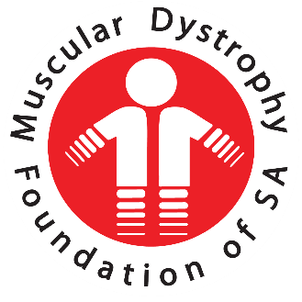

General Manager Statement Sept 2018- Aug 2019

Muscular Dystrophy Foundation of South Africa, Gauteng

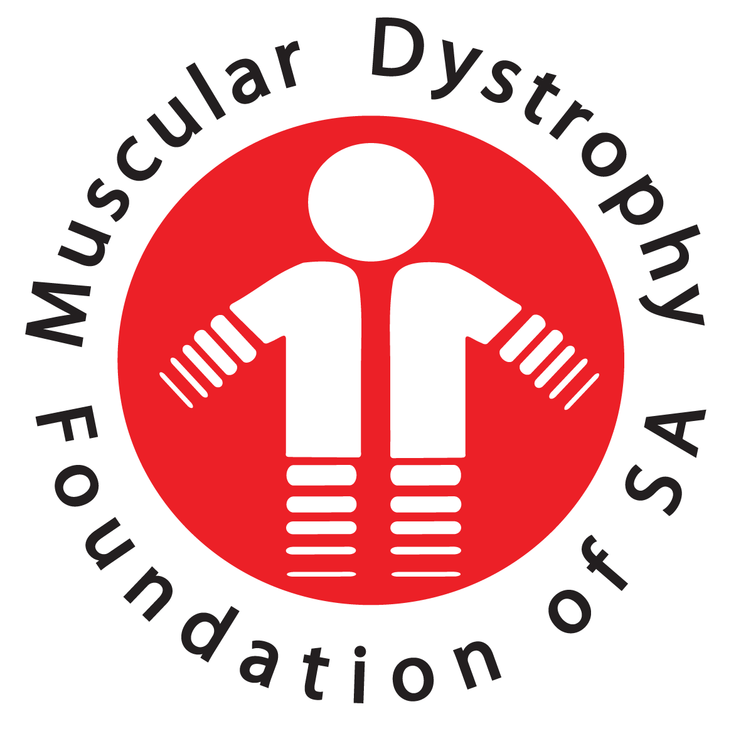

General Manager Statement 2019

Muscular Dystrophy Foundation of South Africa, Gauteng

I have been with MDF for 3 months. It was therefore a bit tricky for me to write a report for this AGM because, traditionally AGM’s are used to take stock of the year that was.

But I am fortunate that the bulk of the programs of the foundation are handled by Social Workers and their report is written & delivered by our Senior Social Worker, Mulanga.

After looking at the situation I decided to write what I believe is more of a statement than a report.

And it will focus on three main issues. Which are:

1. I shall tell you about what I have been doing to orientate myself.
2. Some ideas I have about the future (which I continue to discuss with the staff and consulting our members on. This will later be tabled to the Board once they have been finalised.
3. And lastly, I shall thank our partners and all the people whose efforts enable this foundation to be a vehicle of hope and an agency that avail certain resources that our members need to increase the quality of their lives.

# Feedback from our members

Soon after I got here I decided to accompany our Social Workers on their field trips. I wanted to observe how they do their work and ask our members to tell me how they feel about the work of the foundation, what according them can be improved, cut out and new things that can be introduced.

It was important for me to interact with our members whilst I was still new. MDF is a membership organisation. In a practical sense, this means that MDF exist because and for its members. A definition I got when I Googled this word is: A **membership organization** is an agency that grants its **members** specific rights to participate in its internal affairs.

So, I went to our members whilst I was still new so that I could ask them to tell me who MDF is so that their views can form part of my orientation. I felt that the people who have been granted the right to participate in the internal affairs of this organisation should tell me what it is. And I got a lot from our members.

# Our members need our service

I am pleased to announce to this gathering that all of them still see a need for our service. This is very important because if the result was the opposite, we would have seriously considered whether we shouldn’t dissolve this organisation.

Those of you who know the challenges of people with muscular dystrophy in our country understand why people who are affected by muscular dystrophy appreciate our services. These people are dealing with a serious condition which doesn’t have “easy” solutions. Their life has been changed and they continue to experience more difficulties.

# Approach of our Social Workers

MDF Social Worker is in most cases, one of the few people apart of the medical personnel who is available to listen, provide them with reliable information, allow them talk openly about how this condition and give them a commitment that they available to walk alongside them and will do their best to find some of the things that they need.

It is also often through MDF that a person who had been diagnosed with muscular dystrophy connect with other people who are dealing with this situation. Being part of a community that deals with your most pressing need is invaluable. It was interesting for me to see how our Social Workers handle this aspect of their service. They ask members if they would want to talk or meet with other people or parents of children who are affected by MD.

When they agree the carefully select the people whom they think should be do it. They look at a lot of things including cultural, class, economic status and where both the new client and the old client are in terms of dealing with their condition. Later on, when they follow up, they check if the relationship has worked. If it didn’t work, they set they advise the new client to be free to say if they want to continue meeting their “date” or they want a different person.

They (our Social Workers) told me that they do this because their approach is called “People Centered service”. They focus on the interest of the person who has needs. This very approach makes them to respect the choices of clients even when people do things that they know were “wrong or unwise”. They told me that their role is to provide correct information and avail themselves to support their clients.

# Assistance with equipment

A few have been lucky to get assistance with some equipment from the foundation during the year under review. Those who know the type of equipment’s that our members need and their costs would understand why I say those who were helped were lucky.

Equipment needs of our over 400 members are over whelming. The foundation work tirelessly to raise funds. But unfortunately often get way less than our members’ needs. The other complication is that when we get something, it is not easy to spread it to many of our members because we are dealing with very expensive stuff. This has resulted in some members reaching conclusions that they are being overlooked for one reason or the other.

I have listened to their frustrations and felt for them. Our Social Workers always get our members to fill forms for their equipment needs and keep on telling them to wait. Some of the members end up calling the office. Others come and ask to speak to me. We feel for them and are also frustrated.

When I came in, I found many requests and very little resources. I have since asked our Social Workers to develop a policy that can help us to decide how we allocate the resources. They are busy with it and hope that in due cause we would be able to know what we should do when we get R20 000.00 and there are 8 people who need motorised wheelchairs and 7 who need batteries and 2 who want to helped with genetic testing.

I do not think that this policy will make our decision easy. It will help the organisation to know that we have the best criteria that enable us to allocate resources without using favouritism or allowing those who might be closer to us or who can make noise to jump the queue. It will also enable us to do our best to make all our members feel that they are equally valued.

I have been thinking about our problem of little resources and more needs and I have concluded that it is time we invite our members to be part of the solution. In my over 2 decades of working in the development space, I can tell you that major breakthroughs that I have witnessed almost only happened when there was meaningful involvement of people who are directly affected by the problems that were being addressed.

My aim, which I have already shared with the team here at the office and has been embraced; is to seek ways to mobilise our members and get them to be more involved in the affairs of this Foundation. It is very important for us to involve our members because they are mostly affected by this condition.

When I grew up there was a boy with a name that we couldn’t understand it’s meaning until very late when we were matured. His name was “Gaboutlwelwe”. A direct translation is: It’s not possible to feel a pain of another person”.

When I got to the stage where meaning of words and concepts made sense to me I asked one of the elders to explain this name and she did. I remember the analogy that my aunt used. She said, “Every time I spank your brother, you can’t feel the pain he feels”. That wasn’t rocket science. I did not understand why that known fact was so important that someone has to be called that way.

Later on, when I had been a professional for over 10 years, I realised why it was important for people to be reminded that they can’t feel the pain of others. It is very easy for people who address problems of others to think that they know how those who are on the receiving site feel. It is also easy for providers of service to determine what should be done and define do’s and don’ts.

A few weeks ago, we received an email from one of our members asking about research for cure of the Muscular Dystrophy. The member wanted to know what has been discovered to date and he was also offering to donate some money towards the cost of research in South Africa. It was very difficult for us to respond to the part where he wants to give money towards research because in our country nothing is being done.

Do you know why that is? I am convinced that we are not doing research partly because people who decide what should be done with most of the country’s resources are not directly affected by problems that they are claiming to be addressing. Neither do they pay enough attention to what those who are affected.

MDF wants to keep making sure that those who are affected have a say in the type of services that is renders to them. In the next few weeks we shall call some of our members to more consultative meetings and hopefully by the end of this year we would have mobilised more members and will develop a strategy to involve our members to play a meaningful role in the affairs of the foundation.

# Fundraising & Resource mobilization

MDF Gauteng has been through many changes between 2018 and 2019 but despite everything we managed to have a prosperous year due to many kind hearts that have tirelessly assisted us.

We wish to thank some our biggest sponsors such as the:

* Wetterhahn Foundation
* GS Elkin Charity Trust
* Setzkorn Family Trust
* Kirkness charitable Trust
* Carl & Emily Fuchs Foundation as well as the
* Bradfield Foundation.

We would also like to thank the **Gauteng Department of Social Development** for their long-standing support. There have been so many others who have assisted us on a regular basis that we could not have done it without all of them and we thank you from the bottom of our hearts.

Many events were also held such as the Blue Bottle Golf day, WCCS UJ Golf Day and Redhill School Golf Day which were all an amazing success! Two of our biggest events each year are Casual Day and the Muscle Riders Cycle Team which were both an immense success and we would like to thank everyone that sponsored us and assisted us throughout the year with donations, assistance and TV broadcast time to ensure these events were so amazing for us.

We would also like to thank the **Old Mutual Foundation** for making another generous donation.

We were also fortunate enough to have been donated a Chrysler Voyager with disability modifications by the **Talia family** which has made a huge difference for us.

We wish to thank every single person for their assistance over the last year no matter how big or small, we could not have done it without all of you.

Fundraising report was prepared by Robert Scott – MDF Business Development Specialist

# Social services report

Individual and Family work

Social service professionals conducted 600 visits between September 2018 and August 2019.

School visits and support groups

Support groups were facilitated at the following schools:

* West Rand School, Krugersdorp
* Filadelfia Secondary school, Soshanguve
* Ezibeleni School, Katlehong
* Pretoria School, Prinshof
* Ethembelihle School, Primrose
* Adelaide Tambo School, Soweto

Relationships formed with schools means that when new leaners diagnosed with muscular dystrophy comes to each of the schools above, they let parents know about the Foundation and we are also able to make contact with parents and start working with them.

Other support groups

* Soweto youth club – an ongoing support group for the youth of Soweto living with muscular dystrophy. They meet once a month.
* West Rand School parents support group – A support group for parents of learners at West Rand School.

Community Work / Awareness Campaign

* Katlehong family skills centre – The social worker in Ekurhuleni does awareness at the centre once every month. There, she is also able to form relationships with other organisations.
* Dukathole Main Clinic
* Thelle Mogoarane Regional Hospital
* Steve Biko Academic Hospital – The social worker in the Tshwane area does awareness at the Paediatric neurology clinic. Clinic dates for the muscle clinic are in February, May, August and November.
* Tshwane District Hospital
* Kalafong Provincial Hospital
* Bheki Malngeni Hospital – The social auxiliary worker in Johannesburg / Soweto area does weekly awareness at the physiotherapy dept.
* Chris Hani Baragwanath Hospital – The social auxiliary worker in the Johannesburg/Soweto area does awareness at the muscular dystrophy clinic once every month.

Challenges

* Incorrect contact details on the database make it difficult for social service professionals to make contact with the clients.
* Members in need of equipment but have been on the waiting list for too long.
* Travelling with public transport makes it difficult to reach the targeted number of home visits.
* Tragic loss of the general manager and having to adapt to changes.

Highlights

* Kagisho – Having built a good relationship with Chris from Wheel on The Run. He has gone out of his way to ensure that our members get proper fitted wheelchairs. And he will be assisting with fixing my client’s chair at no cost. Both he and his wife have delivered groceries to one of my clients in need.
* Meeting a great Leader has helped a lot on the field as he does home visits with us and help provide better support to our members.
* Building a good relationship with Social Development in Randfontein and Krugersdorp has helped us in dealing with a case of neglect for one of our clients in the area.
* Mulanga – On 31 October 2018 we visited Pretoria School with gifts for muscular dystrophy learners. Leaners were very happy to receive gifts and were also pleased to meet the general Manager Pieter Joubert.
* On 8 June 2019 Filadelfia school leaners were treated with lunch at Spur and also enjoyed a game of FIFA at the mall.
* Seeing leaners happy warms my heart.

Supervision

Supervision sessions are held once a month for support and empowerment purposes. Social workers and social auxiliary workers share experiences and challenges they face while in the field with the assistance of the supervisor.

Social work report was prepared by Mulanga Kharidzha - Social Worker

# Appreciation

Thank you to staff

Thank you for opening your hearts and minds a new GM after you had been with someone whom you had looked at as a father figure. Your perseverance and dedication are the reasons this foundation is regarded as a friend and allay to our members. Keep it up and continue to do more than you are required. I wish you a bright future ahead.

Thank you to National Office General Manager

Gauteng branch has the privilege of sharing a building with the National Office General Manager. This makes it easy for us to get support quickly. But Gerda is doing way more than overseeing our operation. As an experienced Social Worker, she is often asked to mentor our Social Workers and assist me complex social work issues that comes up. For that I want to say thank you Gerda.

Thank you to all Volunteers

Our work would not be possible without the work of our dedicated volunteers. Members of the committee have ensured that this branch comply with all legal requirements and have helped out in many ways to complement a small staff complement that we have here. Because of this invaluable contribution, we're eager to say a big public "Thank you volunteers! We salute you!"

Respectfully submitted by:



Rabie Modisane

MDF Gauteng Branch(**Provinces of:** Gauteng, North West, Limpopo, Mpumalaga)

**General Manager**

Saturday 27 September 2019