  - Annual Report Sept 2019- Aug 2020
  - Muscular Dystrophy Foundation of South Africa, Gauteng Branch
(Inclusive of: Gauteng, North West, Limpopo, Mpumalanga & Free State)

Annual Report 2019

Muscular Dystrophy Foundation of South Africa, Gauteng Branch
Contents
1. Organisational Details 1
2. The General Manager’s desk 2
3. Social Services Report 4
Individual and Family work 4
Home Visits 4
School visits and Support groups 4
Community Work / Awareness Campaign 4
Supervision and Training 5
Challenges 6
MDF appointed a new Social Auxiliary Worker during the period under review 6
4. Wheelchair Provision and & Service for Members 7
5. Fundraising Report 9

Organisational Details

Mission Statement: To support people affected with Muscular Dystrophy and neuromuscular disorders and endeavour to improve the quality of life of our members.
Board Members:
- Advocate Jan Ferreira – Chairperson
- Rudy Petersen – Vice Chairperson
- Doné Van Eyk – Treasurer
- Hanti van Eyk – Secretary
- Rani Naidoo – Board member
- Lerato Chiloane – Board member
- Gerda Brown – Board member
- Anri Human – Board member
- Masilo Motloutsi – Board member
- Siza Cokoto – Board member

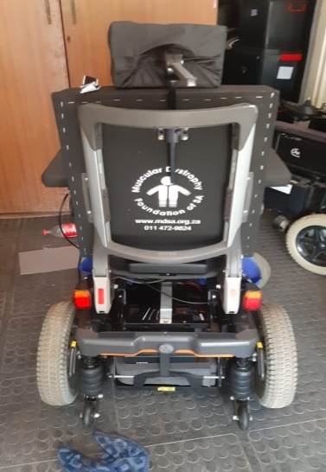

The General Manager’s desk

I joined the Muscular Dystrophy Foundation of South Africa a little over a year ago.
Accompanying our dedicated social service professionals on their field work enabled me to see the difference that this Foundation has made to so many of our members.
Our hard-working Business Development Specialist had managed to write some very good proposals for specialised disability equipment before I came in and a few of them paid out soon after my arrival.
Our board insisted that our priority be focused towards the poorest of our members as they do not have a way to get help if we did not come to their rescue.
This was achieved by instituting an Equipment Application Committee and informing members to provide proof that they could afford to buy equipment for themselves. Whilst this increased paper work and slowed the process a bit – it also pushed us to implement a transparent and fair system of using limited resources in a context where there are vast needs.
The outbreak and spread of COVID-19 interrupted our services in March 2020 when a national lockdown was declared. When Social Workers checked how our members were doing – some said their struggle had gotten worse and we knew that we had to do something. We immediately focused on adjusting to work remotely whilst remaining effective. We were able to direct them how to send requests to us and we managed to provide the same quality of service.
The organisation got very busy and was able to do a lot for the members. As you would see in the Social Work report - we have delivered on our mission of improving the quality of lives of our members. This was made possible by the many role players who continue to contribute to our work.
These include our board members who voluntarily work hard as a governance structure. We thank them and their families for their continued dedication and support. Additionally, institutions that we work with which include all special schools which have MD children attending them. Hospitals who services our members and recognise the importance of the role that we play as an association. A big thank-you to the doctors, nurses and administrators. Our donors & partners who are individually acknowledged in the Fundraising section of this report. Our suppliers who deliver the best service possible to our members and for going the extra mile.
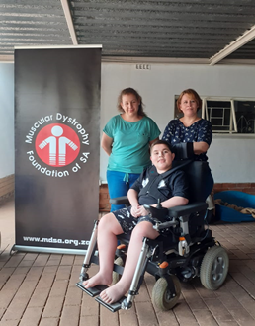
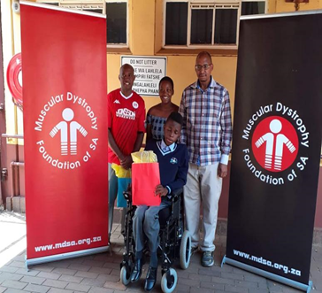

Rabie Modisane
General Manager

Social Services Report

Individual and Family work

Home Visits
- A total of 220 home/work place/ school visits were made by Social services professionals during the period under review.
- Over 600 telephone / texts and email contacts were made to members. Most of those who are serviced by telephone are members in Provinces outside Gauteng which are part of this branch.
- In the midst of the pandemic providing service to members of the foundation has remained our priority.

School visits and Support groups
Support groups were facilitated at the following schools:

- West Rand School, Krugersdorp
- Filadelfia Secondary school, Soshanguve
- Ezibeleni School, Katlehong
- Pretoria School, Prinshof
- Ethembelihle School, Primrose
- Adelaide Tambo School, Soweto

Because of the COVID-19 Pandemic support groups have also been affected. But members are serviced via telephone and some visits are made during extra-ordinary circumstances.
Soweto youth club was terminated in December 2019.

Community Work / Awareness Campaign

- An Awareness event was held at Millenium Primary School in Krugersdorp on the 13 September 2019. One of the Social Workers did a presentation on disability. It touched on various disabilities including Muscular Dystrophy. The learners were very excited and enjoyed the activities which they were engaged in which demonstrated what a disability is.

- Steve Biko Academic Hospital – The MDF Tshwane based Social Worker visited the Paediatric neurology clinic on 7 November 2019 and on 13 February 2020. She addressed parents and shared about the work of MDF. She also distributes pamphlets and MDF magazines to the parents. Visits to these hospitals are good because Social Workers get to meet members from other provinces which do not have Neurology departments. It was good to see some of them from Mpumalanga. The General Manager was also introduced to them.
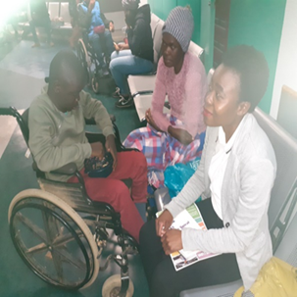
- Chris Hani Baragwanath Hospital – The Social Auxiliary worker in the Johannesburg / Soweto area conducts awareness campaigns once every month on dates where doctors attend to people affected with MD.

- Varsity College – Lynnwood Ridge Pretoria – On 19 February 2020 Social service professionals and the General Manager attended an NGO day to raise awareness about the Foundation and Muscular Dystrophy. MDF gazebo was put up as well as a table and promotional materials such as magazines and pamphlets were put on display. Over 40 students came to the MDF stall and interacted with MDF Social Workers.
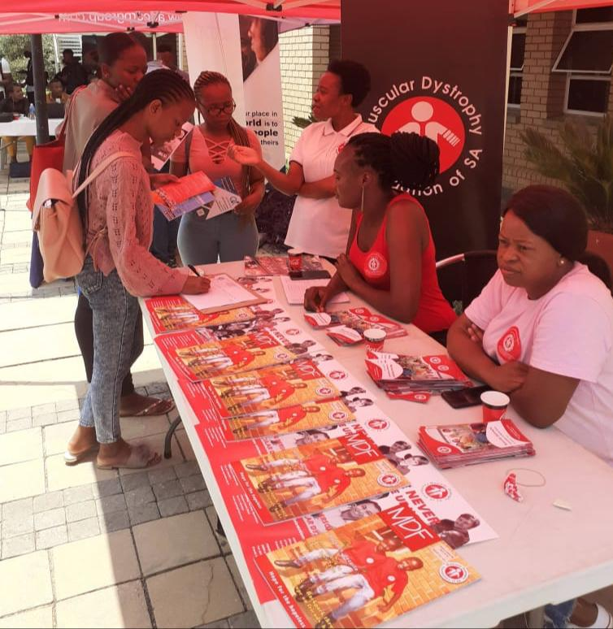

Supervision and Training

- Supervision sessions are held once a month for support and empowerment purposes. Social services professionals share experiences and challenges they face in the field.
- In-Service training sessions are generally held monthly or by-monthly. The National Office General Manager steps in and assists with supervision, training and advice. She is an experienced Social Worker and Gauteng branch Social Workers (who are mostly young Social Workers) benefit from her experience.

Challenges

- Incorrect contact numbers makes it difficult for social service professional to reach members. Other members change their contact details and don’t inform the foundation.
- Other members expect social workers to do tasks that are not their responsibility, like applying for an RDP house for them and assisting them with sanitizers. It is important for members to know the services that we provide and what we can assist them with.
- Language barriers between some of our members when information is written in English, some don’t understand and are afraid to ask.
- It has been difficult to provide service during the COVID-19 Lockdown.

MDF appointed a new Social Auxiliary Worker during the period under review

She shares her journey over the last six months with MDF:
The welcome and warmth that I got from MDF family and members was beyond my expectations. I spent the first week going around with my colleagues to see how they work. During the second week I was introduced to my clients who welcomed and embraced me.
Honestly, at first I was not fully prepared for the emotional challenges that would come with the job but after orientation I gained confidence and then I started to believe more in myself. Working at Muscular Dystrophy Foundation has taught me important skills such as listening carefully to the client especially their needs – but to know and accept my limitations.
I have already seen many different members who are my clients. I also learned how to use a telephone to deal with issues – in cases where I can’t do physical visits. My colleagues taught me the importance of being very clear about what I can do and not to over-promise. Whenever I encounter challenges, my colleagues are always there to assist me.
I am very happy to be part of Muscular Dystrophy Foundation Family.

A Thank you note to MDF from a Member

Dear Muscular Dystrophy Foundation
I'd firstly like to express my appreciation for the constant assistance and role you've played over the years and especially with the very recent assistance by providing me with new wheelchair batteries, a comfortable cushion, a face shield and a full wheelchair service which has helped me a lot in being mobile again and not needing a push.
Life is a struggle that everyone has to constantly battle and being physically challenged makes the struggle even more especially when your disability is incurable. Thanks to technology many of these harsh realities have been reduced.
My COVID-19 experience has been and continues to be a dark cloud of bad luck which has taken away everything I’ve been working towards.

In 2014 I founded a video gaming company "Entertainment Neighbourhood" and my company has been a growing success which was sadly destroyed by COVID-19. I was kicked out from home and i am now renting with a friend forced to sell all my company assets for survival.
I truly couldn't have been assisted with my wheelchair at a better time than now as not only did it make me mobile but it has provided me with hope that I can make it out of COVID-19 alive.
I'm currently looking for employment and I've been applying everywhere, hopefully I'll get a job and afford both a helper and shelter for myself.
Thank you
Lucky Shabalala
066 232 5237
13 August 2020

Wheelchair Provision and & Service for Members

Mobility devices are among the common types of assistive technologies used to improve personal mobility for people with disabilities. These equipment’s are therefore a matter of equity for people with disabilities as they facilitate their access to education, work and social life, increase their independence and enhance their participation in their communities. People with Muscular Dystrophy have specific needs that constantly change, sometimes rapidly, as they progress.
Neuromuscular disorders are often extremely limiting, causing users to become dependent upon others for all activities of daily living. Mobility is one of the few areas that with appropriate provision, people can be fully independent and this should always be the goal. Wheelchairs and seating are vital to the lives of many people with these conditions. Appropriate provision at the right time can maximise independence and delay the onset of postural deformities. Delays and incorrect provision not only waste limited budgets but are extremely frustrating for the user and can be detrimental to their health.
MDF Gauteng has been aware for a long time that wheelchair and seating provision for its members varies considerably. Each person must be assessed and be interviewed by an experienced wheelchair technician who can – to some extent anticipate certain changes such as weight, growth developments and impact of the conditions as per types. This is why MDF Gauteng makes sure when it chooses equipment suppliers. The supplier is required to visit the recipient before-hand to do a full assessment, be able to read the report from Occupational Therapists and interview family members or care givers to get their perspective based on their observations.
They will then be able to build a chair that will be suitable, comfortable and serve a member for a long time. This is the only way to do things right. MDF also educates its members who have been assisted with chairs on how to take care of them, how to preserve battery life and always stresses the importance of servicing them at the right time. The Foundation therefore wishes to encourage its members & their family members, good Samaritans, our government, companies and institutions which may want to assist people with MD with assistive equipment to please get hold of the office before they go ahead purchase chairs.
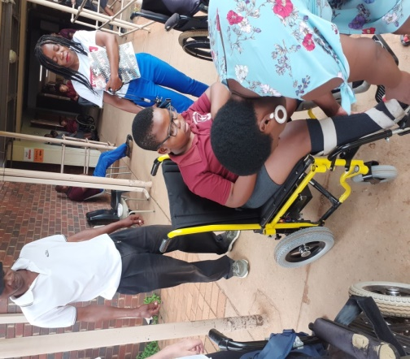

Mulanga Kharidzha
Social Worker

Fundraising Report

MDF Gauteng has experienced many good times and some more difficult times between 2019 and 2020. Despite the difficult times, we have remained focused and secure thanks to our many donors and supporters who have continued to assist us.
We wish to thank some our biggest sponsors such as the:
- The Bradfield Foundation
- Nashua West Rand
- Glencore Cycling Team
- Luso Cycling Club
- Akasia Running Club
- Muscle Riders
- Spoormaker & Partners
- MS Airconditioning Distributors
- Cool Tech
- Tiber Construction
- Blue Bottle Group
- Setzkorn Family Trust
- Ampath Laboratories

We would also like to thank the Gauteng Department of Social Development for their continued and long-standing support as well as awarding us with a generous grant for the purchase of new vehicles for MDF.
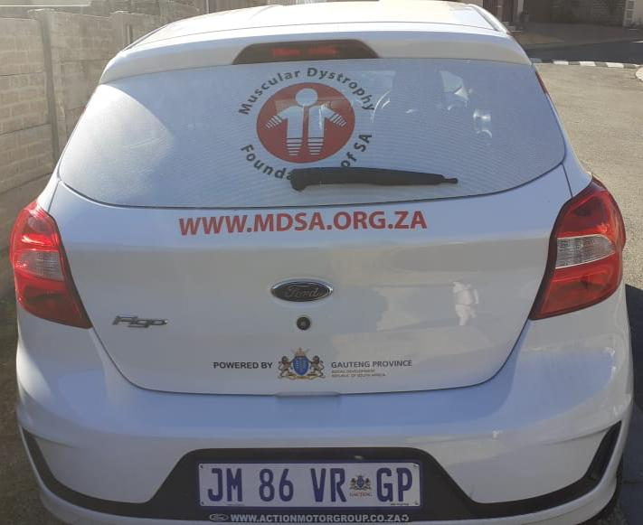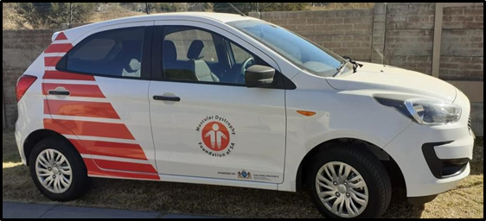

We would also like to thank the National Lotteries Commission of South Africa for their generous grant that has gone a long way in assisting many members in need.
There have been so many others who have assisted us on a regular basis that we could not have done it without all of them and we humbly thank you from the bottom of our hearts.
Numerous events were also held such as the Blue Bottle Golf day, Casual Day 2019 and of course the Discovery 947 Ride Joburg 2019 which was all a wonderful success! We would like to thank everyone that donated, sponsored and assisted us throughout the year.
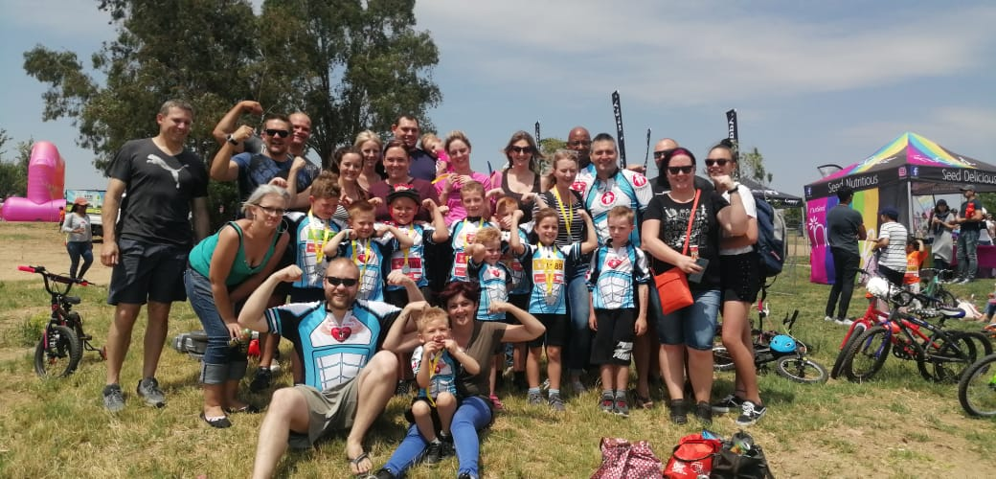
The COVID-19 pandemic has placed MDF in a difficult position in 2020 in that we are unable to host fundraising events. Despite this we will survive, endure and make sure that MDF continues to assist its members no matter how dark the times.
We wish to thank every single person for their assistance over the last year no matter how big or small, we could not have done it without all of you.

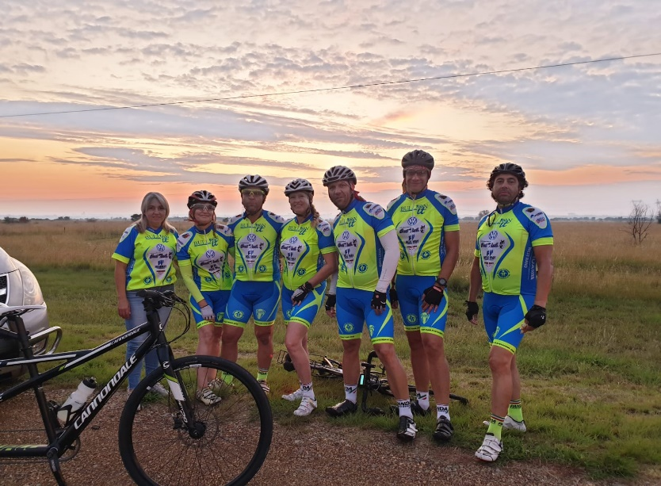
Your support means hope

Robert Scott
Business Development Specialist

