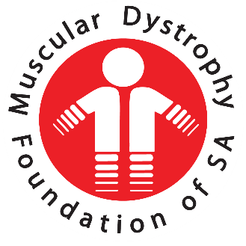
  - Annual Report Oct 2018- Sept 2019
  - Muscular Dystrophy Foundation of South Africa, Western Cape

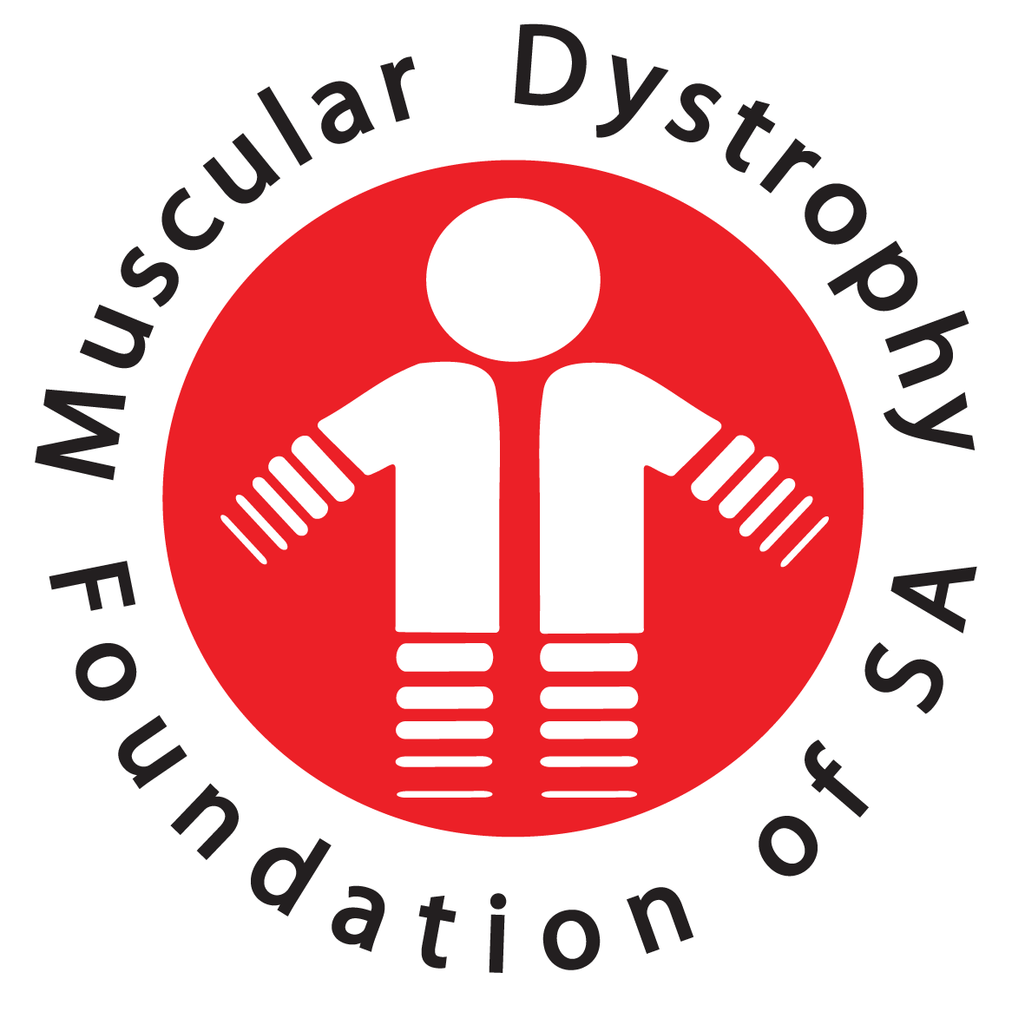

24th Annual Report 2019
  - Muscular Dystrophy Foundation of South Africa, Western Cape

Welcome to everyone present today and thank you for taking the time to join us this morning.
As we did last year we are having our branch AGM at 10am and will move onto our National AGM at 12H00 via Skype.
You are invited to stay and join us for this meeting which should not take long at all.
Refreshments are provided to keep us going. So please help yourselves when we break between the meetings.
- THE OFFICE & STAFF
The Cape Branch continues to grow in numbers as our services develop and spread throughout the community.
As I reported last year, we were curtailing the amount of home visits within the community because of financial constraints and because some areas are not safe. However, the arrangements made to conduct one-on-one visits at schools or the hospitals, workshops and clinics have proved very successful.
Our social workers are very conscientiously making many home visits wherever practical and our members are benefitting very much from these visits.
My sincere thanks to our counselling staff for their conscientious approach to our affected members. Telephonic counselling, counselling via email or WhatsApp are indeed a cost effective manner in which to render services to our members.
The shop and offices have been beautifully restored and upgraded, with invaluable input from Vanessa, and is greatly improved. The new shelving shows off the stock in a much smarter and enticing manner.
We have had a staff change with Abigail Haley leaving us on 18 April and Jade Fairbridge joining us on 18 June.
Our counselling staff at present are:
- Vuyokazi Nkonzombi
- Jade Fairbridge
- Mariam Landers

The second social auxiliary worker post must be filled as Zukiswa Peza left us at the beginning of September.

Our Social Workers continue to be present at the neuromuscular clinic at The Red Cross Children’s Hospital every Tuesday morning. They also attend the neuromuscular clinic at Tygerberg Hospital every second Thursday morning where they follow up care with known clients and introduce themselves to any newly diagnosed persons.
The Social Workers visit special schools and hospitals to promote awareness whenever necessary or when requested to do so.
Their schedule is as follows:
- Tuesday: Red Cross Children’s Hospital
- Wednesday: Astra School
- Every second Thursday: Tygerberg Hospital
- Once a Quarter: Tembalethu School, Vista Nova School, Paarl School and Eros School

I would like to thank the counselling staff for their professionalism in the work they do and for the friendliness and care they show towards their clients.
Thank you, Vuyo, Jade and Mariam
The performance of our branch manager, Vanessa Jordaan, has been excellent. She has ensured that structures are put in place for a smooth running organization and that M.D. policies are adhered to. She has had the combined administrative and managerial responsibilities to manage and has done so with great efficiency and with diplomacy.
The sad news is that Vanessa has been head-hunted by her previous employer to go back to work and she has officially left us on 20 September 2019.
I know that I speak on behalf of the committee and myself when I say that she will be sorely missed and that we thank her for the wonderful job she has done here within the Cape Branch of M.D. She has left huge shoes to fill.
- OUR SUPPORT GROUPS
Our Adult Support group continues on the 1st Saturday of the month under supervision of Vuyokazi Nkonzombi, Jade Fairbridge and Mariam Landers.
My sincere thanks to them for the efficient running of these sessions which provide loving support and gentle upliftment to our members.
I wish to compliment the Adult Support Group team leaders and members for the wonderful support they give one another and for the beautiful camaraderie within the group.

PARENT SUPPORT GROUP MEETINGS
Parent Support Group occurs on a quarterly basis. Within the reporting period this programme has taken on a new nature in order to try a new avenue in developing a support structure that meets the needs of our community of parents. Meetings are held at the Muscular Dystrophy Foundation’s offices, and each meeting targets a different aspect relating to Muscular Dystrophy.
Three sessions were completed during the last year. In total eight (8) parents attended these meetings this year. The meetings included the meetings on the importance of proper seating, the exploration of school challenges, good care and management, the importance of home physiotherapy, and the importance of a healthy diet. Despite the small-scale response with attendance at the parent's support group, an impact was surely made

MUSCULAR DYSTROPHY CHILDREN’S SUPPORT GROUP EVENTS
- Third Term 2018: Treasure Hunt and Family Picnic on 1st September at the Green Point Urban Park:
This was the first time we’d held a treasure hunt and it was a roaring success. My sincere thanks to our committee member Gilda van der Merwe for organizing and making this such a fun and enjoyable occasion for adults & children alike.
The children were lucky enough in the third term to get their annual outing to Grand West Magic Company for a fun filled day as well as the Treasure Hunt. This Grand West outing is always a much loved and anticipated day of joy for our M.D. Children.

- Fourth Term 2018:
This year the children’s year end event was sponsored by The Sun International/Grand West on 7 November. The children spent extra time in the bowling alley as well as the games area. Thereafter they moved over to Wimpy for a lunch and handover of gifts, goodie bags and cupcakes to take home.

- First Term 2019:
On 6 March, we enjoyed a fun-filled crafting morning. The children made beautifully decorated gifts for their moms for Mothers’ Day later in the year. Once again Maggie Ware was the lady leading the workshop.
Early morning muffins and hot cross buns were served with a lunch from Burger King before they left to go back to school.

- Second Term 2019:
We took our M.D. children to Intaka Island at Century City for an educational excursion. It was a long walk for our children but was an excellent learning experience. The bird life at the Island is prolific and children recognized and recorded many different species of birds.

- Third Term 2019:
Our Tuesday 10 September we again held a Treasure Hunt at The Urban Park Green Point to celebrate M.D. Awareness month and World Duchenne Day. This event was organized for children as the change had to be made to suit the school that experienced transport problems on a Saturday.
My sincere thanks to our lovely staff members & Gilda van der Merwe for making the day such a lovely experience for the children. Red balloons galore and so much fun!!
- BRANCH ACTIVITIES
Winter warmers
Mittens were handed to members.
A special thanks to Mrs van Eeden from Knit4 Charity and the lovely ladies who made knee blankets for our M.D. children.

September Awareness Activities
Saturday 7 September: Green Awareness Celebrations at the Branch to start M.D. Awareness month.
Tuesday 10 September: Awareness with M.D. children and World Duchenne Day.
The Adult Support Group kicked off our MD Awareness month with a “Green” celebration at our Branch. There was a unique Bingo game which tested our knowledge to the limits. Lots of photographs were taken and posted on Facebook.
- BARGAIN SHOP
Our “new look” shop is very smart now and the stock fresh and interesting. To keep it exciting we require new stock regularly. Please be on the lookout for good quality second hand goods or as they say “Gently Used” items.
My sincere thanks to each and every lady who take a turn once a week come rain or shine, to support us here at Muscular Dystrophy Cape Town, helping us to raise much needed funds.
The total raised for the year was R14 595.00.
- GOLF DAY
We held our annual Golf day with the Goodwood Rotarians on 12 October 2018. Last year’s golf day raised the grand amount of R20 000.00
My sincere thanks to the Goodwood Rotarians and to Judy Bird for assisting in making this event a huge success. My sincere thanks to Sanjay Narshi and Anne-Marie Stoman for their cheerful and unstinting support at the annual event.
- FUNDING
Our National office can no longer afford to fund the branches. There will be no funding from National until the financial situation improves for them.

DEPARTMENT OF SOCIAL DEVELOPMENT
We are extremely fortunate to have received funding from The Department of Social Development this year for the amount of R709 210.00. This funding is for salaries and a small amount is for administrative costs.
2 Social Workers and 2 Social Auxiliary Workers
Salaries for these 4 posts are covered by DSD.
We affiliate ourselves very closely with The Department of Social Development and this affords us opportunities for outreach programmes using some of their services within the community. Because of their funding to us, it is mandatory that they undertake an audit of our financial statements and visit our office for an on sight visit. This is a very thorough audit of everything we have and every service that we provide. Because we pride ourselves on being a well –structured, totally transparent and a fair organization with no discrimination of any kind, solely working towards improving the life-style and comfort of anyone who has Muscular Dystrophy, we value these visits and the support which The Department of Social Development gives us. Regular feedback to The Department of Social Development is of supreme importance to maintain this subsidy.

FUNDRAISING
Rovos Rail has very kindly offered a trip for 2 on their luxury train from Cape Town to Pretoria or vice versa, as a prize for a raffle for funds for M.D. National. R5000.00 is included for flights on the other end of the destination.
Each branch has been requested to sell as many tickets as possible to assist with the fundraising. The prize is valued at R67 500.00 and tickets are R300 each with only 700 tickets being sold.
Please assist us in supporting this big fundraise drive.
The competition runs from 9 September until 13 December. The draw will take place on 17 December 2019. The prize can be taken up until 30 September 2020.
LOTTO FUNDING
We were again fortunate enough to receive funding from The National Lotteries Board this year to the value of R1 136, 571.00. This is project funded, meaning that they have selected certain projects from those we submitted for funding.
The projects they have funded are:

7 x motorised wheelchairs: R483 000.00
7 x Bipap machines: R275 471.00
Cushions and mattresses: R30 000.00
Renovation Costs to 3 Wiener Street: R158 100.00
Salaries Administrative Staff: R130 000.00
Repairs and Maintenance: R50 000.00
Accounting and Bookkeeping Fees: R5000.00
Bank Charges: R5000.00

We are so grateful for this funding and it is encouraging for us as we are operating under our own NPO number now, and perhaps this is speeding up the process.

As with the Department Social Development accurate invoices for all items bought must be supplied to them as proof of purchase for a recipients of goods invoiced and supplied.
- EQUIPMENT BANK
We continue to service, upgrade and supply wheelchairs to our members when financially possible.

In the past year it has been extremely difficult for us to afford the maintenance and repairs of ageing wheelchairs. This allocation from Lotto will be a great help to us as we could then look at taking some of the older chairs out of service as the cost becomes prohibitive to maintain.

Our sincere thanks to Theunis Hattingh for his excellent service to the Muscular Dystrophy Foundation.

We have not provided wheelchairs in the period of October 2018 - September 2019 as we depleted the Lotto funding in the previous year and no further funding was available.

Repairs and maintenance to the value of R51 507.78 have been carried out on existing equipment.

- COMMITTEE:
My sincere thanks to my committee for their time and for the support given to Muscular Dystrophy. I appreciate all you do towards ensuring that the work of our branch goes on and that our members, or indeed any person affected by Muscular Dystrophy, are cared for to the very best of our ability.

- UPCOMING DATES TO DIARISE
- Monday 7 October Cape Branch Committee Meeting
- Friday 11 October Golf Day/Milnerton Golf Club
- Saturday 2 November ASG Meeting
- Wednesday 6 November MD Children’s Year End Function
- Monday 11 November Committee Meeting
- Wednesday 27 November Volunteers Luncheon
- Saturday 7 December Last ASG Meeting
- Friday 13 December 2019 Office closes
- Monday 6 January 2020 Office Re-opens

WIN VAN DER BERG
CHAIRPERSON

