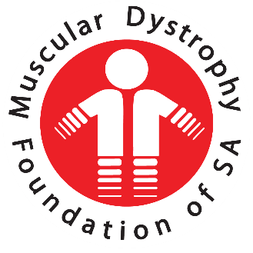
  - Annual Report Sept 2019- Aug 2020
  - Muscular Dystrophy Foundation of South Africa, Cape Branch
(Inclusive of Western Cape, Northern Cape and part of the Eastern Cape)

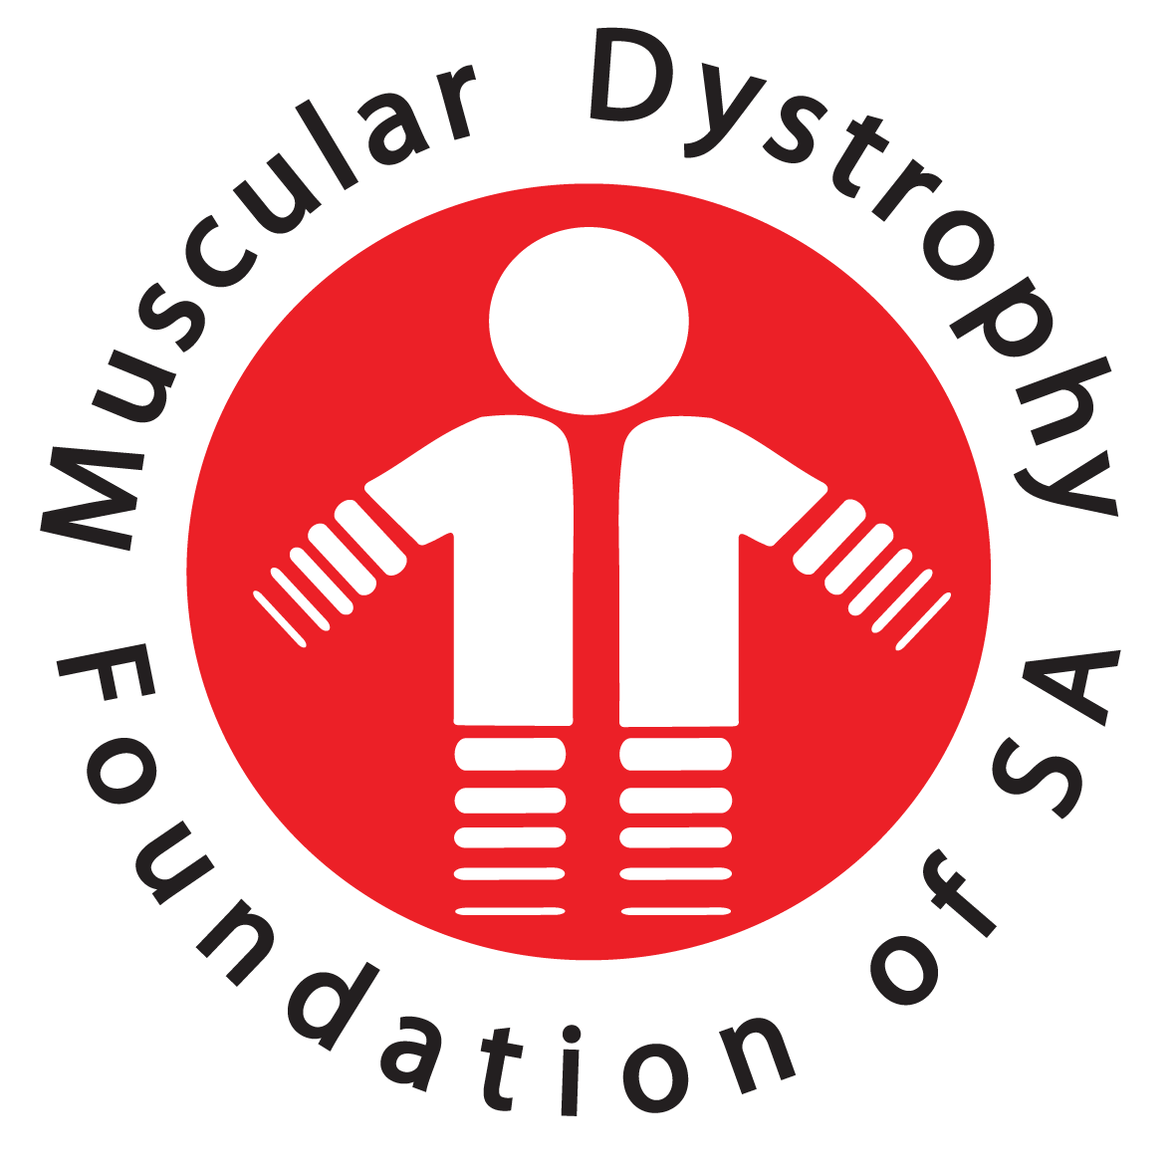

Annual Report 2020
Muscular Dystrophy Foundation of South Africa, Cape Branch

Contents

1. OFFICE AND STAFF 2
1.1. COUNSELLORS 3
1.2. ADMINISTRATOR 3
2. SERVICES AND SUPPORT 3
2.1. MUSCULAR DYSTROPHY CHILDRENS SUPPORT 3
THIRD TERM 2019 3
FOURTH TERM 2019: 4
2.2. ADULT SUPPORT GROUP 4
2.3. BRANCH ACTIVITIES 4
WINTER WARMERS 4
BARGAIN SHOP 4
GOLF DAY 4
3. FUNDING 4
3.1. DEPARTMENT OF SOCIAL DEVELOPMENT 4
3.2. LOTTO FUNDING 5
4. NEW EQUIPMENT SUPPLIED TO MEMBERS 5
5. BUILDING UPGRADE AND MAINTENANCE 6
6. COMMITTEE 6
7. NATIONAL: 6
8. SOCIAL WORK REPORT 7
8.1. CASEWORK 7
Red Cross Children’s Hospital 7
Tygerberg Hospital 7
Multi-Disciplinary Team Meetings (MDT) 7
School Counselling 8
Home Visits 8
Office Counselling 8
Telephonic and Email Counselling 8
8.2. GROUP WORK 8
Adult Support Group 9
Parent Support Group 9
Tembaletu School Muscular Dystrophy Support Group 9
Eros School Muscular Dystrophy Support Group 9
Astra School Muscular Dystrophy Support Group 9
Astra LSEN School Duchenne Muscular Dystrophy Support Group 9
Vista Nova MD Group 10
Paarl School MD Group: 10
8.3. WHATSAPP AND TELEPHONE SUPPORT LINES: 10
Adult Support Line 10
Teen Support Line 10
8.4. COMMUNITY WORK/AWARENESS 11
School Based Awareness 11
Hospital, Libraries and Clinic Awareness 11
Community Centre Awareness 11
8.5. HIGHLIGHTS 11
8.6. CHALLENGES 11
8.7. CONCLUSION 12

Welcome to everyone present today and thank you for taking the time to join us this morning.
As we did last year, we are having our branch AGM at 10:00 and will move onto our national AGM at 11:00 via Microsoft Teams.

You are invited to stay online and join us for the national AGM meeting which should not take long at all.

OFFICE AND STAFF

Unfortunately, Covid 19 took its toll on us as it did with everyone else in the world. In the first 3 months of lockdown only basic assistance was rendered if an emergency arose. For most of the time it was very quiet. Thereafter our auxiliary counsellors worked from home in a very limited capacity.

  - COUNSELLORS
Our two full-time counsellors both resigned and left our services. One at the end of February 2020 and the other on 7 March 2020. We were the process of advertising their posts and were ready to conduct interviews when lockdown occurred. We were then unfortunately forced to abandon replacing these staff members. We are once again in the process of conducting interviews to fill these posts. Vanessa and Dianne are conducting the preliminary interviews and I will join them on Skype when they have shortlisted the candidates. Hopefully they should be able to commence duties on 1st October 2020. At this point I need to commend Mariam Landers especially and Nomfundo Faku also for their diligence and dedication in supporting our clients. They have been awesome during this difficult time.

  - ADMINISTRATOR
We were extremely fortunate that we were able to appoint Dianne de Graaf as our Office Co-ordinator just before lockdown. She has been a valuable asset to us on an administrative level as she fulfilled her tasks and was also able to guide our other two staff members through the Personal Protective Equipment procedure when coming back to work. In other words, keeping everyone safe in their workplace as well as monitoring visitors.

SERVICES AND SUPPORT

In the immediate future we will be making sole use of telephonic counselling, email or WhatsApp. This is the most practical approach and it is also the method the Department of Social Development advocates. As yet we are not able to visit hospitals or schools to pursue our usual support activities, therefore also no support group meetings can take place. Our members are a high-risk group of people and need to be protected as much as possible. I have been in contact with the neuromuscular doctors Red Cross Children’s Hospital and with Dr Henning at Tygerberg Hospital and they were able to assist us with emergency cases during lockdown.

  - MUSCULAR DYSTROPHY CHILDRENS SUPPORT

THIRD TERM 2019
On 10 September 2019 we took the children to the Urban Park in Green Point to celebrate “World Duchenne Day”. The theme was red and included a fun-filled treasure hunt organised and donated by Gilda van der Merwe. It was once again an exciting day for the children with photo sessions, gifts and lots to eat.
This is such a fun event and we’re all bitterly disappointed we cannot hold this event again this year.

FOURTH TERM 2019:
The children were once again taken to Grand West for their Christmas spoil. The fun morning was followed by lunch at Wimpy and Christmas gifts to take home.

  - ADULT SUPPORT GROUP
On 7 September 2019 we had a social gathering at our Community Centre to celebrate Muscular Dystrophy Awareness month. The order of the morning was based on the “Get into the Green Scene” campaign. Lots of fun, photos and eats.

Further meetings were held at our Community Centre namely:
- Body Stress Relief workshop in November 2019
- A Valentine’s Day celebration in February 2020
- Caregiver Stress and Support workshop in March 2020

There was no further support groups held.

On 7 December 2019 our year end function was a bring and brunch function. It was an enjoyable event with fun and games with dear friends wishing each other well over the holiday season. 4

  - BRANCH ACTIVITIES

WINTER WARMERS
Once again, a special thank you to Gloria Van Eeden and her team from Knit 4 Charity. They made beautiful mittens, beanies and knee blankets for our members.

BARGAIN SHOP
Our hardworking ladies who assist us in our shop raised R1632.00 in the period October 2019 to March 2020. A sincere thank you to each lady who supports us so kindly by serving in the shop once a week. We are most grateful to you all.

GOLF DAY
The annual golf day with the Goodwood Rotarians on 4 October 2019 raised R20 000.00. My sincere thanks to Sanjay Narshi and Anne-Marie Stoman for their solid assistance at this annual event.

FUNDING

  - DEPARTMENT OF SOCIAL DEVELOPMENT
We are extremely fortunate to have received funding from the Department of Social Development for the amount of R709 210.00. This funding is salaries for our social services staff with a small amount included for administrative costs. As you will have observed in my earlier comment, two of our senior staff members left us at the end of February / beginning March 2020. As we were unable to fill these two posts because of Covid 19 we have requested the Department of Social Development to allow us to use the unused salary monies to purchase solar panelling to put on the roof to cut down on our Eskom bill. We await a reply from them in this regard.

We affiliate ourselves very closely with the Department of Social Development and this affords us opportunities for outreach programmes using some of their services within the community. Because of their funding to us, it is mandatory that they undertake an audit of our financial statements and conduct an onsite visit. This is a very thorough audit of everything we have and every service we provide. As we pride ourselves on being a well-structured, totally transparent and fair organisation with no discrimination of any kind, solely towards improving the lifestyle and comfort of anyone who has Muscular Dystrophy, we value these visits and the support which the Department of Social Development gives us. Regular feedback to the Department of Social Development is of supreme importance to maintain this subsidy.

  - LOTTO FUNDING

We were again fortunate to receive funding from the National Lotteries Board to the value of R1 136 571.00. This is project funded. We received monies for the following:
- Accounting and bookkeeping fees
- Bank charges
- Equipment consisting of wheelchairs, Bipap machines, cushions and mattresses
- Personnel salaries and benefits
- Renovations
- Repairs and maintenance

NEW EQUIPMENT SUPPLIED TO MEMBERS

We are in the process of supplying 9 new motorised wheelchairs to our members.

We were able to purchase 2 Bipap machines to date to assist members with severely compromised lung capacity.

We are grateful for this funding and it is encouraging for us, operating under our own NPO number now, that we are able to assist more of our members.
Reporting back and accountability is of extreme importance if you want to be considered for future funding from Lotto.

BUILDING UPGRADE AND MAINTENANCE

As you may have noticed when you were last able to visit our Community Centre, our building and surrounding area is looking very neat and tidy.
We completed the maintenance work before we closed in December 2019 and we are enjoying working in this nicely improved environment.

I am pleased to report that having the approach to our main entrance repaired makes wheelchair access a real pleasure now and less hazardous. Also the new drainage system at the back of our property is a great improvement and no flooding problems so far this winter.

COMMITTEE

My sincere thanks to my committee for their time and for the support given to Muscular Dystrophy.

I appreciate all that they do towards ensuring that the work of our branch continues and that our members or indeed any person affected by Muscular Dystrophy is cared for to the best of our ability.

To this end, I would like to suggest that all future committee meetings be held via Skype or Zoom until we are free of the Covid 19 pandemic and feel it safe to conduct face-to-face meetings once again.

NATIONAL:

I would also like to thank our National EXCO chairman and committee for their guidance and support throughout the year.

A special word of thanks to Gerda Brown for her dedication to Muscular Dystrophy and for her exemplary training sessions with our staff and for her continual support and encouragement to our branch.

Win Van Der Berg
Chairperson

SOCIAL WORK REPORT

The following report provides an in-depth representation of the services rendered by the Muscular Dystrophy Foundation: Cape Branch from October 2019 to September 2020. The report elaborates on services such as caseload, related services, group work, support lines, community work and awareness. Furthermore the report focuses on the highlights and challenges faced by the organisation throughout the service year.

  - CASEWORK
Casework at the Muscular Dystrophy Foundation: Cape Branch refers to counselling services wherein social service staff work directly with affected persons, families and medical professionals in order to ensure that all the medical, care, social and emotional needs of members are met. Currently, the branch has 365 members and open cases.
Between October 2019 to September 2020 35 new memberships have been completed and 6 cases closed. An average of 120 families receive casework services from social service staff each month. A total of 724 contacts/meetings have occurred during the last year. These are discussed in detail below:
Social workers work closely with the Neuro-muscular Out Patient Department clinics at Red Cross Children’s Hospital (RXH) and Tygerberg Hospital (TBH). The social workers attend Red Cross Children’s Hospital once a week on a Tuesday and Tygerberg Hospital every second Thursday for multidisciplinary meetings. Clients are either seen directly at these clinics or meetings occur between various professionals to ensure a holistic care plan for clients.

Red Cross Children’s Hospital
Between October 2019 and September 2020 130 in-clinic assessments were completed with families and 34 additional individual counselling sessions were completed at Red Cross Children’s Hospital.

Tygerberg Hospital
Between October 2019 and September 2020 38 individual counselling sessions were conducted by social workers with affected individuals at Tygerberg Hospital.

Multi-Disciplinary Team Meetings (MDT)
Separate to the attendance of clinics, social workers work closely with other helping professionals to determine holistic care plans for clients. Between October 2019 and September 2020, 36 separate meetings about clients have been conducted and follow-up intervention plans implemented.

School Counselling
Social workers work closely with learners in Special Education Needs (LSEN) Schools in the Cape Town area namely: Astra LSEN School, Eros LSEN School, Tembaletu LSEN School, Paarl LSEN School and Vista Nova LSEN School.
Strong working relationships also exist between the Muscular Dystrophy Foundation Cape Branch and Jan Kriel LSEN School, AGAPE LSEN School and Lentegeur LSEN School. These schools are not visited on a regular basis, however interdisciplinary services and care are coordinated and implemented via these relationships.
Special emphasis is placed on working with mainstream schools where affected members are placed. Social service staff work closely with teachers in this regard to ensure understanding of the condition and that appropriate school-based support is provided.

Home Visits
Home visits were conducted depending the area and safety thereof. Between October 2019 and September 2020 17 home visits were completed.

Office Counselling
Social workers regularly run individual and family counselling sessions at the Muscular Dystrophy Foundation Cape Branch offices. During the reporting period 16 counselling sessions were conducted.

Telephonic and Email Counselling
Telephone and email contact with clients has been an exceptional service to render. This permits regular contact and counselling with clients who reside in remote areas and cannot travel to Cape Town. This also allows the social workers and social auxiliary workers to conduct regular follow-ups with clients. Social workers are able to organise services from other organisations e.g. home-based care, addiction counselling etc. During the reporting period 1300 of these contacts were made.
  - GROUP WORK
Group work at the Muscular Dystrophy Foundation Cape Branch refers to extensive therapeutic counselling and skills development that occurs in a group setting. Currently, there are 8 group work programmes running. Each of these is developed to accommodate a different age group and care need. In total 23 group work sessions were facilitated within the reporting period.

Adult Support Group
Adult Support Group occurs on the first Saturday of each month at the Muscular Dystrophy Foundation Cape Branch offices. There were 5 open group work sessions run. The group has focused on living well with Muscular Dystrophy and has covered various topics relating to Muscular Dystrophy and their carers. There have been a few social sessions which allowed members to engage with each other at their own discretion.

Parent Support Group
Parent Support Group occurs on a quarterly basis. Within the reporting period this programme had only 1 session whereby 2 parents attended.

Tembaletu School Muscular Dystrophy Support Group
Group meetings are held on a quarterly basis at Tembaletu School. This group is facilitated by the Social Auxiliary Worker and all learners with different diagnoses of Muscular Dystrophy attend. There were 2 sessions conducted within the reporting period. This group is incredibly effective and well attended. It focuses primarily on teaching life skills and skills related to condition management. This group plays a crucial role in evolving a support system for Guguletu and Khayelitsha based Muscular Dystrophy families.

Eros School Muscular Dystrophy Support Group
This program is held quarterly at Eros LSEN School, and renders group work services to 6 children who all live with a different diagnosis of Muscular Dystrophy. This group is facilitated by the Social Auxiliary Worker and all learners with different diagnoses of Muscular Dystrophy attend. This group is effective and well attended. It focuses primarily on teaching life skills and skills related to condition management. It plays a significant role in managing the cases at Eros LSEN School and in identifying individual support required. There was 1 session completed during the reporting period

Astra School Muscular Dystrophy Support Group
Group meetings are held on a quarterly basis at Astra LSEN School. Between October 2019 to September 2020, the group initially had 15 members. The group focuses on the provision of therapy and life skills to all children affected with various types of Muscular Dystrophy. It plays a crucial role in managing the cases at Astra LSEN School and in identifying individual support required. There were 3 sessions conducted during the reporting period

Astra LSEN School Duchenne Muscular Dystrophy Support Group
Boys with Duchenne Muscular Dystrophy at Astra LSEN School are divided into 2 support groups based on their age. These 2 groups are run by the Social Auxiliary Workers on a weekly basis every Wednesday. On occasion the 2 two groups combine for a joint meeting. The group runs according to school academic terms with each term addressing a different skills programme. Meetings focus on teaching basic life skills and skills focused on condition management. The work conducted in these groups is therapeutic resulting in an effective programme. There were 9 group work sessions run within the reporting period and 9 boys are currently provided with individual counselling services. Within the reporting year there were 9 group members, however one member passed away in June 2020 and one learner transferred to Eros LSEN School.

Vista Nova MD Group
This group happens once a term and is facilitated by the Social Auxiliary Worker. There are 4 group members actively participating in this group. The group focuses on therapeutic life skills and condition management. There was 1 session done for the reporting year.

Paarl School MD Group:
This group is facilitated once a term by the Social Auxiliary Worker. The group consists of 7 learners affected with various types of Muscular Dystrophy. The group work focuses on condition management and therapeutic life skills. There was 1 session done for the reporting year.

  - WHATSAPP AND TELEPHONE SUPPORT LINES:
The Support Line programmes play a very significant role in service delivery of the Muscular Dystrophy Foundation Cape Branch. This service provides support and encouragement to members of the Muscular Dystrophy community by strong community leaders who also live with Muscular Dystrophy. These leaders have become a great example to other members of how life continues after diagnosis and that a healthy and happy life is feasible.

Adult Support Line
Ms Anne-Marie Stoman (MDF committee member) with assistance from Mr Sanjay Narshi (MDF treasurer) facilitates the Adult Support Line. This service caters for our adult members and plays a crucial role in maintaining support and ongoing interaction. Ms Stoman reports back to the social workers and they render additional support as required.

Teen Support Line
Mr Jaco Arendse (MDF member) coordinates the Teen Support Line Group. This group caters for young adult members of the Muscular Foundation Cape Branch.
This service plays a crucial role in maintaining support and ongoing interaction among peers. Mr Jaco Arendse reports back to the social workers and they render additional support as required.
  - COMMUNITY WORK/AWARENESS
Community Work/Awareness is facilitated by the Social Auxiliary Workers at the Muscular Dystrophy Foundation Cape Branch. This programme has been initiated to reach out to local communities to spread information about the condition. These services play a crucial role in addressing discrimination and stigmatization in our communities, as well at educating healthcare and education professionals about the condition. Overall community work and awareness leads to increased referrals and improved service delivery. In total 3 awareness events were completed within the reporting period.

School Based Awareness
School based awareness programmes provide students and educators with insight about Muscular Dystrophy and adequate information on how to care for the needs of our members with whom they interact regularly. During this year 1 awareness campaigns occurred.

Hospital, Libraries and Clinic Awareness
Conducting awareness within medical settings provides insight to medical staff members at our Community Day Hospitals and Clinics which enables them to work effectively with Muscular Dystrophy patients. It also allows social services related to Muscular Dystrophy to be incorporated in disadvantaged communities placing emphasis on appropriate referrals to the larger medical facilities for in-depth treatment and support services. The social auxiliary workers facilitate the community awareness programme and 1 awareness programme was conducted during the reporting period.

Community Centre Awareness
Touching base with local community centres plays a crucial role in educating our local communities about Muscular Dystrophy. Our Social Auxiliary Workers conducted 2 awareness sessions at various locations within local communities during the reporting period.

  - HIGHLIGHTS
- New management coming on board.
- Returning back to work.
- Being able to assist our clients with food parcels and assisted devices.

  - CHALLENGES
- Lack of transport for members to fully engage with the organisation’s services.
- Challenge in contacting clients because of their numbers changing.
- Death of 6 members.
- Not being able to visit schools, hospitals and do awareness programmes.

  - CONCLUSION
Within the last year the services provided by the Muscular Dystrophy Foundation Cape Branch has been less than what the organisation usually provides due to the Covid 19 lockdown. Despite various challenges faced throughout the year, the organisation has managed to assist clients with check-in calls and assisted devices. The upcoming year will focus on the maintenance and improvement of current services. Thank you to all those who have assisted with and supported the social services rendered by the Muscular Dystrophy Foundation Cape Branch.

Mariam Landers Nomfundo Faku
Social Auxiliary Worker Social Auxiliary Worker

