  - Annual Report 2018
  - Muscular Dystrophy Foundation of South Africa, Gauteng Branch

Introduction
Muscular dystrophy (MD) is the name given to a group of more than 40 different neuromuscular disorders, resulting in progressive wasting and weakness of the muscles. Each of the different types of MD presents with various levels of severity and complexity. Progressive muscle weakness is the primary symptom, leading to secondary effects such as fatigue, increasingly limited physical activity, impaired balance and frequent falls.

Who and what is the MDF of South Africa?
The Muscular Dystrophy Foundation (MDF) of South Africa was founded in September 1974 and registered on 20 December 1999 in terms of Section 18(a) as a not-for-profit volunteer organisation. NPO 004-152 has reference. The MDF supports people affected by muscular dystrophy and neuromuscular disorders. The foundation currently consists of a National Office in Johannesburg, with branches in the Western Cape, Gauteng and Kwa-Zulu Natal.

Gauteng MDF
The geographical area covered by the Gauteng Branch includes the Free State, Mpumalanga, Limpopo and North West provinces.

We are located in Florida Park, Roodepoort. The executive committee of our Gauteng Branch is made up of dedicated volunteers, affected and unaffected with MD.

Role of the Gauteng MDF
Our role is to support individuals affected by MD and their families by
- offering comprehensive medical information, referrals to neurologists and genetic counselling;
- providing links to specialised health services;
- assisting with special disability equipment;
- facilitating contact to support groups and emotional support; and
- providing regular news updates.

Gauteng MDF services
- Medical information: We refer affected persons to neurologists, genetic counsellors and specialist clinics. We provide specific medical fact sheets on each special type of muscular dystrophy and neuromuscular disorder. Booklets and information about muscular dystrophy are distributed to general practitioners (GPs), hospitals and clinics. Our awareness events, informational leaflets and posters, regional radio and newspaper features, all support our awareness outreach to the public.
- Physical health: The MDF Gauteng offers information on neuro-physiotherapists and other specialist therapists and services.
- Occupational health: The gift of maintaining independent mobility with the aid of special equipment is of invaluable support to the disabled person and to his or her caregivers. The vision for our rehabilitation services is to maximise the functional capabilities of our members in order to minimise the impact of their disability as far as possible, so that they may maintain a healthy and independent life-style.
- Support and care: The MDF has a network of MD type-specific support and general support contacts. We encourage the formation of support groups. The MDF offers information on care via referrals to counselling, social services and bereavement counselling. We also offer links to agencies for nurses and caregivers, lists of residential care centres and more.
- Awareness and news: Generating support for our foundation is vital to expand our awareness efforts and extend our reach.

- GAUTENG BRANCH REPORT FOR OCTOBER 2018

Dear members and friends of the MDF
Welcome and thank you for your presence at MDF Gauteng’s 22nd Annual General Meeting. It is a privilege to deliver the General Manager’s Report.

  - Governance
Executive Committee
The Gauteng Branch Executive Committee comprised nine members in the following portfolios:
Jan Ferreira (Chairperson), Rudy Petersen (Vice-chairperson), Leanne Opperman (Treasurer), Suretha Erasmus (Secretary), Lerato Chiloane, Theuns Langenhoven, Marnie Potgieter, Rani Naidoo, Doné van Eyk.
Monthly committee meetings are held via Skype.
Strategic Objectives for 2017/2018
A strategic planning session was conducted on 10 February 2018. Attention was given to the following objectives:
Objective 1. Facilitate and co-ordinate advocacy, awareness and public education programmes regarding muscular dystrophy.
Objective 2. Facilitate and co-ordinate outreach to members (including social worker intervention and provision of equipment) and update the database.
Objective 3. Facilitate and co-ordinate governance and management.
Objective 4. Facilitate and co-ordinate fundraising event programmes.

  - Structure and services
The executive committee cares for the integrity and legal status of the Gauteng Branch, and it actively directs and supports fundraising to sustain and grow our activities. The committee plans the strategies for every year and is directly involved with project proposals. Every operational decision is subject to the approval of the entire committee and is executed in liaison with the General Manager.

Growth and development
Fundraising
Awareness and news

Services
Medical information
Physical health
Occupational health
Support and care

MDF Gauteng Structure

Treasurer
Leanne Opperman

Vice-Chairperson
Rudy Petersen

Chairperson
Jan Ferreira

Business Development Specialist (Admin)
Robert Scott

Social Worker
Mulanga Kharidzha

General Manager
Pieter Joubert

Cleaner
Emily Motaung

Social Worker
Beauty Mathebula

Social Auxiliary Worker
Kagisho Mkuchane

Social Auxiliary Worker
Rudzani Mukheli

Office and staff
We renewed contracts of our social workers and social auxiliary workers with funding received from the Department of Social Development. Our social workers, Mulanga Kharidza and Beauty Mathebula, play significant roles in being aware of the needs of our affected members and anticipating where assistance can be provided and is needed. Our social auxiliary workers, Kagisho Mkuchane and Rudzani Mukheli, assist with home visits and awareness.
Thank you to Robert Scott, Development Specialist, for all his efforts with fundraising. Every year we have different fundraising events such as participating in Casual Day and cycle challenges to raise funds, all in aid of the affected members of the MDF.
We are very grateful to DSD for the grant of R617 544 that they made available towards salaries for social services and administrative costs for the current financial year.
Our National Office reduced the grant of R10 000 to R8 000, then to R5 000 and subsequently to R3 000 due to financial constraints until March. Unfortunately the grant had to be taken away in the new financial year.

Support and care
Support group sessions are presented at schools by social workers and social auxiliary workers when allowed by schools. Our social worker Mulanga Kharidzha will deliver her report.

Finances
Due to the bad economic climate that people and companies are finding themselves in, it has become extremely difficult to raise funds. In an ever-demanding society the challenge to raise funds for the services rendered by a charity organisation becomes bigger day by day. It is our responsibility to obtain the funds necessary to support our members.
We are grateful, however, for the support of individuals and companies who care for the well-being of our affected members. We received another donation of R50 000 from the Wetterhahn Foundation towards the building of a hydro pool. This brings the total amount raised to R100 000, invested with Stanlib. We would like to thank Mr Wiehahn from the Wetterhahn Foundation for their continued support.
  - Donations
Generous donations by private persons and companies, trusts, and faith-based organisations have made it possible for the Gauteng Branch to assist disabled members with special equipment like motorised wheelchairs, bath lifts, batteries, wheelchair repairs and much more.
NLC application – In the last call for applications the NLC received in excess of 16 000 applications with requests amounting to approximately R40 billion in funding. We received an amount of R141 000 on 18 December towards the purchasing of specialised equipment and operational costs. We are grateful for the grant received and wish to thank the National Lotteries Commission for the support that they give to charity organisations.

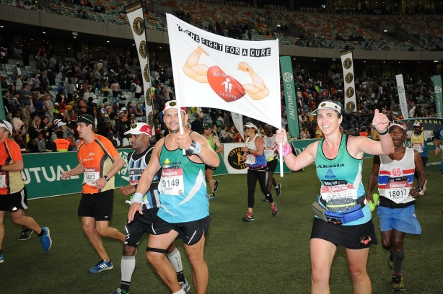
  - Events
Comrades Marathon on 10 June 2018 – Naomi Janse van Rensburg from the Akasia Athletic Club took part in the marathon and crossed the finish line with a flag that said she was running for people with muscle-wasting conditions. We wish to thank Naomi for her support.
Muscular Dystrophy Workshop – We had a workshop on 1 September 2018 at West Rand School, Wentworth Park, Krugersdorp. We wish to thank Mr Chris Coetzee, Principal, for allowing us to make use of the school facilities. Mrs Antoinette Human gave a talk on the importance of education. Ms Kerry Walsh gave an inspirational talk and shared her experience of living with SMA. Mrs Kerrie Austin showed the handling of patients and stretching exercises.
The workshop had been registered with the Wits Health Consortium for CPD points, and we received 3 points for the event, which was well attended.
We would like to thank Mrs Mariska van der Walt, Deputy Director: Persons with Disabilities from Social Development for sponsoring breakfast and lunch for 150 people.
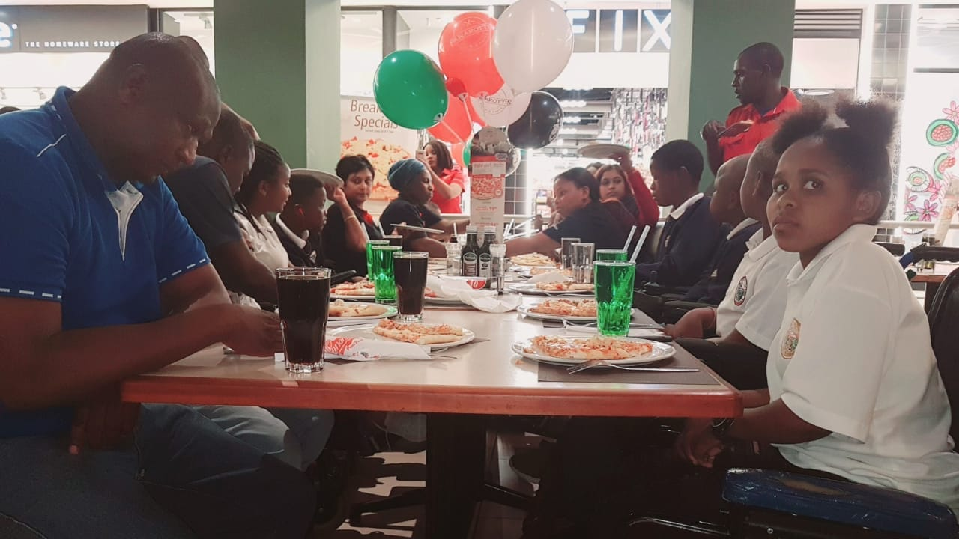
Ezebeleni School – On 6 September MD learners were treated to lunch at Mugg & Bean, East Rand Mall. They had folded fillers and milkshakes. The outing was enjoyed by the children.
Ithembelihle School – On 26 September MD learners were treated to lunch at Panarotti’s, East Rand Mall. They had pizzas and milkshakes. They enjoyed the outing.
  - Fundraising activities
Telkom 947 Cycle Challenge on 19 November 2017 – Our TV advertisement, produced by Foghound Studios, was aired on MultiChoice and e-TV from August until 15 October 2017.
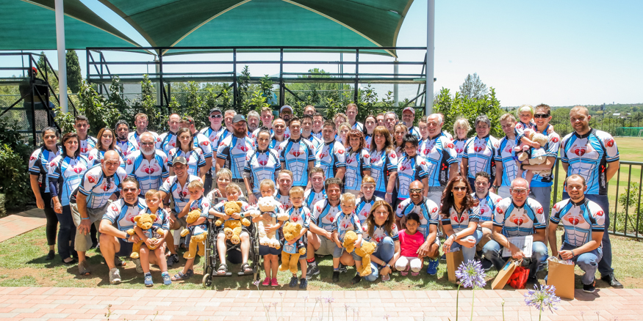

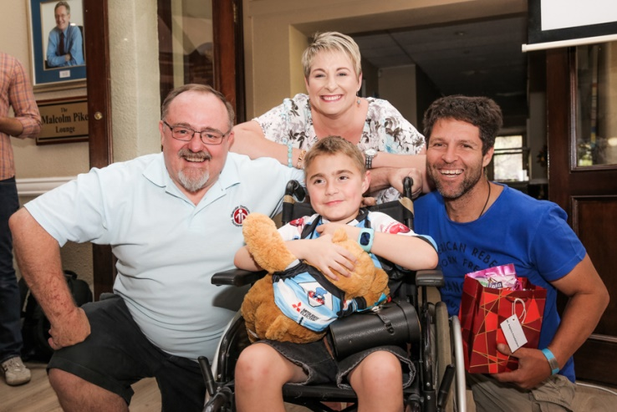
We had 112 cyclists who completed the Telkom 947 Cycle Challenge road race on 19 November and 6 children who completed the “Kiddies Ride” on 11 November.
Ludick Fouche, 8 years of age and affected with Duchenne MD, Angelos Frantzeskos and a large group of Muscle Riders completed the chariot pull in a time of 4 hours and 32 minutes. Thank you to Theuns Langenhoven, staff and all cyclists for making the day a big success.
Thank you to our sponsors. Mitsubishi Electric (Pty) Ltd and Spoormaker & Partners sponsored our cycle jerseys. Blue Bottle Group donated R25 014 to MDF Gauteng as part of the Telkom 947 Cycle Challenge 2017.
Our appreciation function was held on Saturday, 18 November at Crawford College, Lonehill. Thank you to the Principal, Mr Ingo Vogt, for the use of their facilities and to Ms Kate Meintjies for organising the set-up. Cyclists were given their race packs and goody bags, which contained a Muscle Riders LED key ring and various sweets.
Jason Greer, TV presenter, was master of ceremonies. Gifts sponsored by Ilze-Mari Fourie of Distell and certificates of appreciation were handed to sponsors. Thank you to the WCCS UJ Chapter for their volunteers who assisted on the day. Roza Langerman, Zelda Fourie, Litza Roodt, and Rani and Mano Naidoo for assisting wherever possible. Dee-Ann Kaaijk from Strike A Pose did the photography on the day.
Lastly we would like to thank our sponsors Eskort Princess Crossing, Florida Junction Super-Spar, Tru Juice and Paarman Foods for assisting with the catering. Cash donations received towards refreshments and hospitality gazebo space from CE Mobility, John Leamy Insurance, Qualimark Printers, and CoolTech (Pty) Ltd. Cyclists were given water sponsored by Clover and brownies sponsored by Mr Dean Martin after the race.
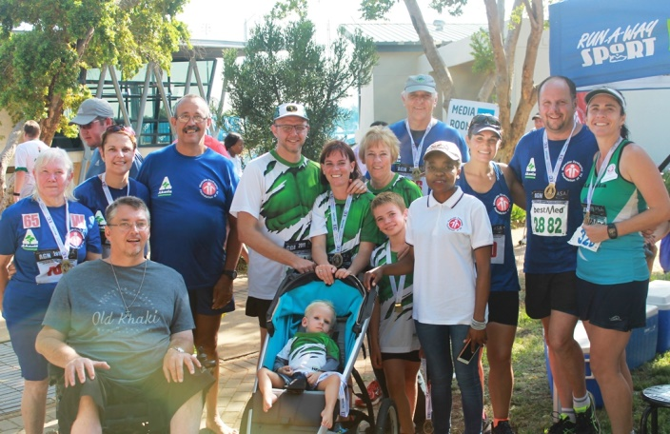
We ranked eleventh among the top fundraising charities with a total of R330 621.99 raised from all cycle challenges last year.
BestMed Tuks Race, 17 February 2018 – The Akasia Athletic Club and MDF Gauteng took part in the 2018 BestMed Tuks race at the UP sports campus at the University of Pretoria. The Akasia Athletic Club donated R20 000 on top of donations of R12 584.61 received. The overall amount raised was R34 414.61. We would like to thank the Akasia Athletic Club, Anri Human and all the participants who made this an incredible fundraiser for the Foundation.
Redhill School Fundraiser – On Saturday, 4 November Redhill Private School together with Suco Yoga in Sandton hosted a wellness Saturday – something for the body, mind and spirit. The morning was held primarily to help raise money and awareness for muscular dystrophy and MDF Gauteng. This event raised R2 205.
2018 Johannesburg to Cape Town Cycle Tour – The tour started on 28 February 2018. Once they arrived in Gordon’s Bay, cyclists had the choice to stay and participate in the Cape Town Cycle Tour 2018 or join the group in cycling back to Travalia. Angelos Frantzeskos, the team leader, was interviewed on Monday, 26 February (08:20) at the Breakfast Show Mix93.8FM studio in Midrand. Lotus FM also interviewed Karan Singh on 10 March at 18:30 about the tour and Foundation.
The cyclists completed 1 359 km. Media coverage was done on the Eden 93.8 FM radio station. The group of cyclists raised a total amount of R115 579.43. They raised funds for Jason Howieson, affected with Duchenne MD. The wheelchair was presented to Jason at the Brewers Fish & Grill restaurant in Rietfontein on Sunday, 15 April 2018.
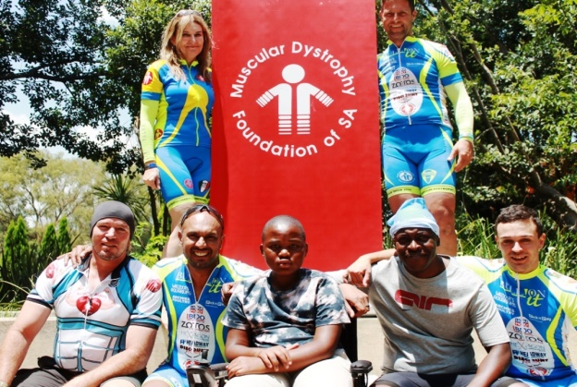
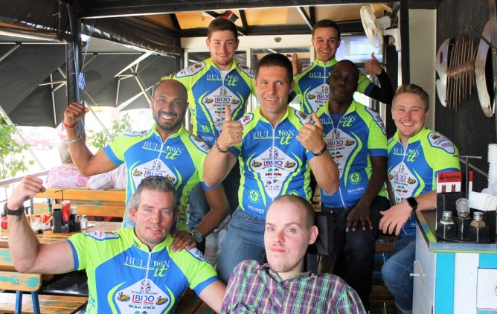

Pictur
WCCS
UJ Golf Day – The WCCS UJ Chapter hosted their annual Golf Day on 8 March 2018 at the Jackal Creek Golf Estate to raise funds for their delegates to attend the 40th WCCS AGM here in Sandton, South Africa. A percentage of the funds raised from the event will also go to support the Muscular Dystrophy Foundation Gauteng.
Art from the Heart – We obtained a donation from Supreme Moldings of items consisting of mounted paintings, painted canvases, frames and décor items to be used for a fundraiser. Supreme Moldings framed 19 of the donated canvases free of charge. On Saturday, 26 May we sold some of the artwork at the Crouse Art Gallery and also at our offices. The total amount raised so far amounts R11 150.
Casual Day project – We operate independently from other organisations and applied for the Muscular Dystrophy Foundation to become a national affiliate of Casual Day. Casual Day organisers have informed us that the Foundation has been accorded full recognition and made a national affiliate of Casual Day. We participated again this year and received R4 of each R10 from stickers sold. We sold 2 831 stickers and raised an amount of R16 909.70. Once the audit has been completed we will also receive a percentage of the funds that are made to the national beneficiaries.

  - Awareness
Generating support for our foundation is vital to expand our awareness efforts and extend our reach. The MDF name and logo have become well known and supported.
Our annual awareness events give people a heart for muscular dystrophy and encourage support of our foundation. The MDF Magazine shows the positive developments of our programmes.
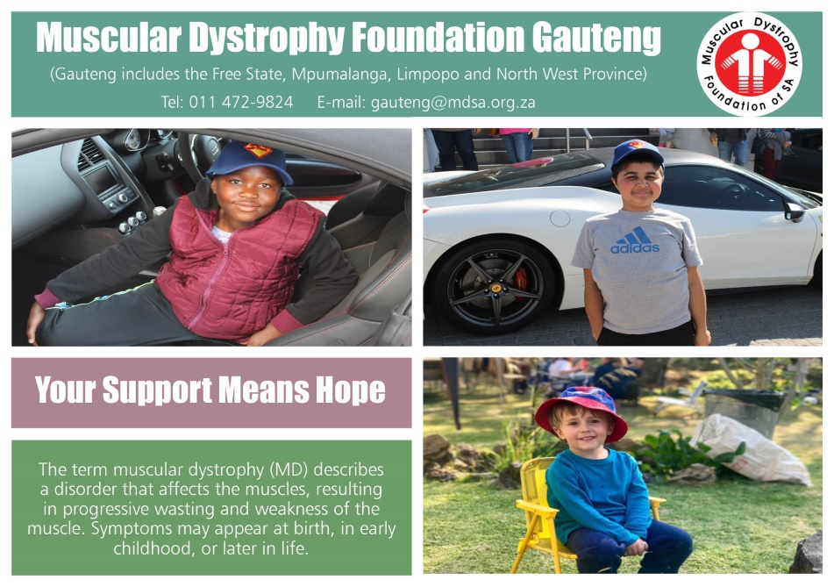

Awareness campaigns were conducted in schools, clinics and organisations.
The daily Theta Show on SABC1 held a talk about disabilities and muscular dystrophy on 22 March. An article titled “Anyone can be extraordinary” about Bernadette Francois, affected with SMA, and the Foundation was published on 22 March in the Fourways Review newspaper. An article about Pieter Joubert and MDF Gauteng using art to raise much needed funds was published in the Roodepoort Record on 26 May 2018.
Frontshop Pharmacy Magazine published an MD ad during the month of March.
An article calling for Casual Day support for MDF Gauteng was published in the Fourways Review on 24 August 2018.
On 29 July 2018 Pieter Joubert and Robert Scott gave a talk about muscular dystrophy and the Foundation on RSG.
On 12 August 2018 Anzel Fouche, mother of Ludick Fouche, did an interview with RSG about Duchenne MD.
On 8 September 2018 Pieter Joubert gave an awareness talk on Sirius FM radio station.
On 18 September Pieter Joubert and Robert Scott gave a talk about MD and our Muscle Riders cycling team on the Worlds Sports Wrap Show on Radio Today Johannesburg.
Our new 30-second Muscle Riders TV advertisement, produced by Foghound Studios, was broadcast between August and October this year. The value of the MultiChoice broadcast slots is R805 000, and e-TV promotions were valued at R598 000.
  - Social Work Support

Meetings
Consultations Meeting with the Department of Social Development
On 2 and 3 October 2017 the social worker in the Ekurhuleni area attended the consultations meeting. The meeting was to discuss the following:
- The NPO Partnership Model and Transformation Plan
- The NPO Sector Funding Policy Guideline. A Sector Guide for the Non-Profit Organizations
SABC Disability Summit 2018
On 18 April 2018 social workers attended the SABC Disability Summit 2018. The summit was about career options, and they managed to gather information to share with muscular dystrophy members on recruitment agencies, higher education enrolments, career guidance agencies, and skills training agencies. MDF pamphlets and magazines were also distributed.

Supervision
Supervision sessions are held once a month for support and empowerment purposes. Social workers and social auxiliary workers share experiences and challenges they face while in the field with the assistance of the supervisor.

Workshops
Muscular Dystrophy Workshop
Social workers and social auxiliary workers attended the muscular dystrophy workshop hosted at West Rand School on 1 September 2018. The workshop was well attended by families and affected members.

Individual and Family Work
Home visits
Social workers and social auxiliary workers conducted 598 home visits between October 2017 and September 2018.
School visits and support groups
Support groups were facilitated by both social workers and social auxiliary workers at the following schools:
- Filadelfia Secondary School
- Ezibeleni School
- Pretoria School
- Ethembelihle School
- Adelaide Tambo School
- West Rand School
- Hope School
Soweto Youth Club – This is an ongoing support group for the youth of Soweto who are living with muscular dystrophy.
Parents support group Ekurhuleni – This is a WhatsApp support group for parents, who share information as well as challenges.
Adult support group Ekurhuleni – This is a WhatsApp group for adults with muscular dystrophy.

Community Work / Awareness Campaign
Awareness was done at the following places:
- Tamaho Clinic
- Katlehong Family Skills Centre
- Germiston Clinic
- Alberton North Clinic
- Bertha Qxowa Hospital
- Edenvale Hospital
- Tembisa Hospital
- Wannenburg Clinic
- Villa Lisa Clinic
- Dukathole Health Clinic
- Tsakane Main Clinic
- Chris Hani Baragwanath Hospital
- Mofolo Clinic
- Bheki Mlangeni Hospital
- Chawelo Clinic
- SK Matseke Hospital
- Steve Biko Academic Hospital
- Dr George Mukhari Academic Hospital
- Skinner Street Clinic
- Mamelodi Hospital

Challenges
Due to the use of public transport we are unable to provide the service of a home visit to all our clients. We sometimes have to walk long distances to reach a client’s home.
We spend most of our time at taxi ranks waiting for taxis to become full when travelling to see clients.
Some members cancel appointments on the day, making it difficult to arrange appointments with other members for those times at short notice.
As social workers, we find ourselves conducting fewer home visits than we should because there are members who say that they do not require home visits.
Incorrect contact details on the database make it difficult for the social workers to contact the clients.

General
CHBAH Pediatric Muscular Dystrophy Clinic – Dr Marc Hauptfleisch has started a muscular dystrophy clinic at the Chris Hani Baragwanath Hospital. The clinic takes place on a single day each month, and visits are by appointment only.
  - Equipment
Thirty-four members were assisted with various types of equipment and with repairs in the 2017/2018 financial year.
Eight members were assisted with motorised wheelchairs, one member with funding towards a wheelchair, thirteen members with batteries, five members with back rests and cushions, two members with tube mattresses and pumps, and five members with wheelchair repairs.
Nine members have been assisted so far in the current financial year with various types of equipment: three members with batteries, three with wheelchair repairs, two with a monetary shortfall on wheelchairs, and one with a head rest.
We wish to thank our donors for the donations received.
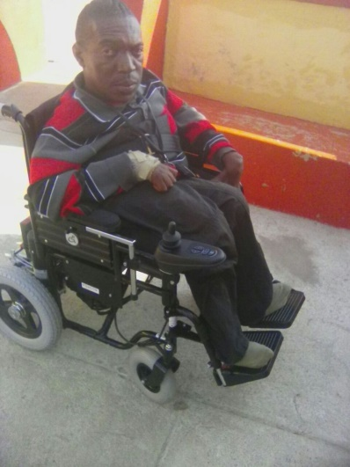
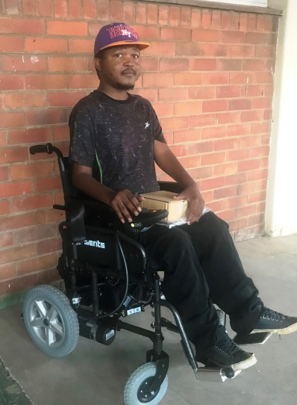

  - Appreciation
Our sincerest gratitude goes to Mrs Elinor Richards, our bookkeeper of Rosebank Accountants, and also to Mrs Siobhan May from SGM Auditing Inc Chartered Accountants, who have been auditing our books.
  - Donation
Photocopy machine – Nashua West Rand donated a new photocopy machine with scanner.
Vehicle donation – We received a donation of a 2005 Chrysler Voyager from the Talia family. The vehicle has been modified for wheelchairs with a motorised lift, making it an excellent asset.
Vehicle branding – Corpnet has sponsored new branding on the rear window of the Chrysler Voyager.
Trade mark registration – We have received the certification for our Muscle Riders (name) registration. The next renewal date of these trade marks is 23 July 2025, and in order to maintain the registrations the renewal fees will need to be paid on or before this date.
SARS – We received a tax clearance certificate of good standing from SARS.
  - Committee
Thank you to everybody who served on the committee. We appreciate your loyalty and commitment to the Foundation.
Thank you to our staff for your support and service to our members and families.
I would also like to thank those members who offer their assistance and time, and all members for your continued support. Your support and assistance during the past year is most sincerely appreciated.
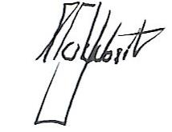
Pieter Joubert
General Manager

