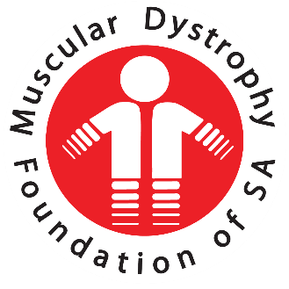
  - Annual Report 2018
  - Muscular Dystrophy Foundation of South Africa, Cape Branch

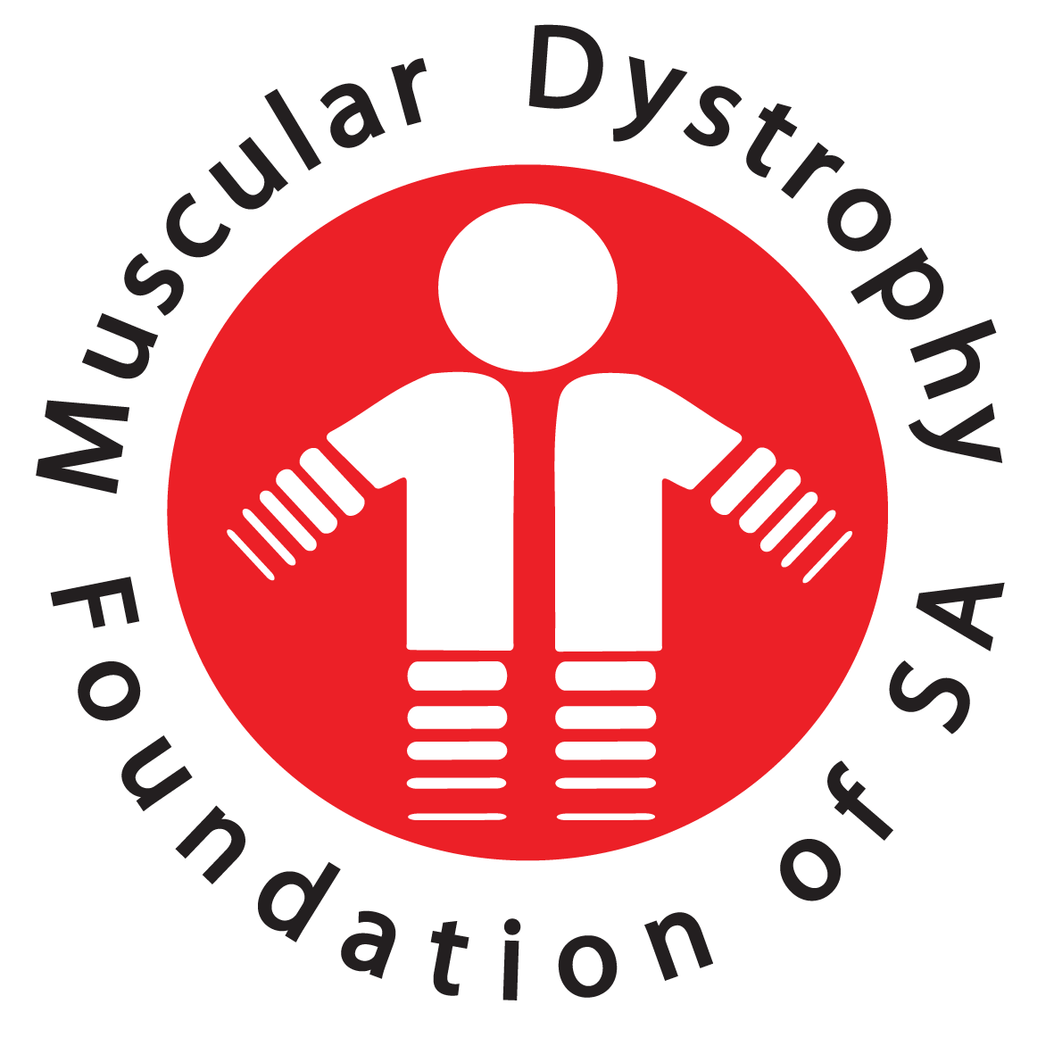

23rd ANNUAL GENERAL MEETING HELD OF THE MUSCULAR DYSTROPHY FOUNDATION, CAPE BRANCH - 27 OCTOBER 2018
REPORT PERIOD: OCTOBER 2017- SEPTEMBER 2018
Welcome to everyone present today and thank you for taking the time to join us this morning.
As we did last year we are having our branch AGM at 10am and will move onto our National AGM at 12H00 via Skype.
You are invited to stay and join us for this meeting which should not take long at all.
Refreshments are provided to keep us going. So please help yourselves when we break between the meetings.
- THE OFFICE & STAFF
The Cape Branch continues to grow in numbers and activities however we have had to change the manner in which we serve our members.
Due to severe financial retraints we’ve had to curtail our social workers visiting families at their homes. We are instead using our time at the schools and hospital visits to arrange one-on-one appointments with members. Our social workers extend their hours at the hospital or school and make appointments at these venues for individual counselling. In a way this is perhaps more effective as the client is already at the venue. Otherwise clients visit our office for appointments with the social workers. Because of the change as explained above, telephonic counselling has increased and when available also counselling via email and/or wattsapp. Wattsapp is indeed a very useful tool which we use extensively.
The storms of the past winter really did great damage to the back rooms of our building. The three rooms at the back were flooded twice and really the water level was a good 60cm up in the rooms. The damage to stock and the building was severe but fortunately we are insured and were able to refurbish the rooms to possibly look even better than before.
However much of the stock had to be dumped and bags and bags of soggy goods were thrown away.
A special word of thanks go to Vanessa and her husband, Abigail, Vuyo, Linda and Mandy and all The Bargain Shop ladies for the concerted effort they put into cleaning up the mess.
The shop has a smart new look, thanks to our own design expert, Vanessa.
Well done ladies!
At present our staff consist of Vanessa Jordaan, Branch Manager, Abigail Haley, Social Worker, Vuyokazi Nkonzombi, Social Worker, Mariam Landers, Social Auxiliary worker who joined us on 23 July 2018 and Zukiswa Peza, Social Auxiliary Worker who joined us on 3 September 2018. I would like to thank them for their dedicated work with our members and for the great teamwork within the branch structure.
Our Branch Manager, Vanessa Jordaan, has proved to be a valuable asset to our branch. She has absorbed the administrative responsibilities into her managerial duties and I & the Committee thank her most sincerely for being willing to assist us in this manner. I would like to thank her especially for her diligence in managing our branch activities and for the supervising of staff affairs. She is extremely efficient in all she does and ensures that we keep to our deadlines, which makes a smooth and efficient office environment.
Our Social Workers continue to be present at the neuromuscular clinic at The Red Cross Children’s Hospital every Tuesday morning. They also attend the neuromuscular clinic at Tygerberg Hospital every second Thursday morning where they follow up care with known clients and introduce themselves to any newly diagnosed persons.
The Social Workers visit special schools and hospitals to promote awareness whenever necessary or when requested to do so.
Their schedule is as follows:
- Tuesday: Red Cross Children’s Hospital
- Wednesday: Astra School
- Every second Thursday: Tygerberg Hospital
- Once a Quarter: Tembalethu School and Eros School
- OUR SUPPORT GROUPS
Our Adult Support group continues on the 1st Saturday of the month under supervision of Abigail Haley and Vuyokazi Nkonzombi. I wish to compliment the Adult Support Group team leaders and members for the wonderful support they give one another and for the beautiful cameradie within the group.
The Parent Support Group meetings have almost fallen away. The Social Workers experience difficulty in grouping parents of differently aged children together. By collectively addressing a group with mixed age children, more emotional problems are triggered. Therefore sometimes, smaller groups of one or two parents only is preferable. Cost of travel and distances between the parents also makes it difficult to form a similar needs group. This is a shame but it is a very real problem in knowing how best to assist our parents. Our social workers are addressing this problem and are now looking at one or two parents meeting at a time with them and/or putting similarly matched parents in touch with each other and using wattsapp as a communication tool for parents.
- MUSCULAR DYSTROPHY CHILDREN’S SUPPORT GROUP EVENTS
We continue with our once a term outings or events for the children to provide stimulation and make them feel special with their own organized programmes to look forward to.
  - CHRISTMAS OUTING 2017
Our Christmas outing in November 2017 was to the Cape Town Museum which was educational and was followed with a picnic lunch in the Gardens with gifts handed out to the children.
  - 1ST TERM 2018
This terms activities for the children was model building. Our group was too large for one morning. We therefore divided the children into 2 groups on separate mornings, as the intricate wooden sculptures the children built needed more space.
The boys enjoyed hot chocolate & muffins on arrival and then set to work building different automobiles and The Eifel Tower. After that tricky work a Spur meal was provided for lunch. The children were given a goodie bag to take home to share with their siblings.
  - 2nd TERM 2018
On May 16 the children were taken on an excursion to the Two Oceans Aquarium which was a great success. The children particularly enjoyed touching seaweed, star fish etc. A picnic lunch was provided for the children by Mandy Green. Our sincere thanks to Mandy for this kind gesture.
  - 3RD TERM 2018 AWARENESS MONTH- WORLD DUCHENNE DAY
On 1 September we celebrated World Duchenne Awareness Day. Red was the colour of the day to celebrate this occasion, everyone held at least 2 red balloons. It was fun with lots of photgraphs which we shared on facebook and our website.
  - 5 SEPTEMBER 2018 – ANNUAL GRAND WEST OUTING
On 5 September it was the children’s annual fun day outing to Grand West. The children had a light meal in the morning at Wimpy Restaurant. Later they played ten pin bowling and spent time in the Magic Company with free tokens which allowed them to play games to their hearts content.
Our grateful thanks to Reach for a Dream for their support again this year. A cool fun day for everyone.
We plan to move the fun day to the fourth term from next year as our Family Fun Day and The Children’s fun day clashed in September.
  - BRANCH ACTIVITIES ( SEPTEMBER AWARENESS MONTH) –BEANNIES AND KNEE BLANKETS
Our Branch committed to collecting warm knee blankets and beanies for our members to help ease the winter’ blues”
We were generously supported by the ladies of The Edgemead Retirement Club, who kindly made all of the articles for our members. Our sincere thanks to The Edgemead Retirement Club for their support and Wally of The Goodwood Rotarian Club for facilitating this donation.
  - FAMILY TREASURE HUNT -VENUE: GREEN POINT URBAN PARK (1 September 2018
The event this year was a Treasure Hunt organized by Gilda. The children had their Treasure hunt first, which saw the children collecting exciting items to wear ie caps, masks, whistles etc.
The adult hunt followed the childrens’ event and there were plenty of exhausted adults afterwards needing refreshments.
This event was a great success and needs to be repeated as everyone really enjoyed the “fun” element of the day.
- FUNDRAISING
My congratulations to the ladies who run the shop for us. Our “new look” shop. Is very smart now and the stock fresh and interesting. To keep it exciting we require new stock regularly. Please be on the lookout for new folk who can supply the shop with good quality second hand goods or as they say “Gently Used” items.
My sincere thanks to each and every lady who take a turn once a week come rain or shine, to support us here at Muscular Dystrophy Cape Town, helping us to raise much needed funds.
The total raised was R24 886.00. Although this is a significant drop from previous years, it is still an awesome achievement.
  - GOLF DAY
We held our annual Gold day with the Goodwood Rotarians on 12 October. Last year’s golf day raised the grand amount of R20 000.00
My sincere thanks to the Goodwood Rotarians and to Judy Bird for assisting in making this event a huge success. My sincere thanks to Sanjay Narshi and Anne-Marie Stoman for their cheerful and unstinting support at the annual event.
  - FUNDING – NATIONAL
Because of very difficult financial constraints our National office has stopped funding to the branches indefinitely. Naturally this has had a very negative effect on our financial situation.
  - DEPARTMENT OF SOCIAL DEVELOPMENT
We are extremely fortunate to have received funding from The Department of Social Development this year for the amount of R671 603.00. This funding is for salaries and a small amount is for administrative costs ie: salaries for our
2 Social Workers and 2 Social Auxiliary Workers
We affiliate ourselves very closely with The Department of Social Development and this affords us opportunities for outreach programmes using some of their services within the community. Because of their funding to us, it is mandatory that they undertake an audit of our financial statements and visit our office for an on sight visit. This is a very thorough audit of everything we have and every service that we provide. Because we pride ourselves on being a well –structured , totally transparent and fair organization with no discrimination of any kind, solely working towards improving the life-style and comfort of anyone who has Muscular Dystrophy, we value these visits and the support which The Department of Social Development gives us. Regular feedback to The Department of Social Development is of supreme importance to maintain this subsidy.

  - LOTTO FUNDING

We were fortunate enough to receive funding from The National Lotteries Board this year to the value of R279.960.00. This is project funded, meaning that they have selected only one of our projects which we submitted for funding.
The project they have funded is for equipment viz. motorized wheelchairs and a Bipap machine. We are extremely grateful for this funding and it is very encouraging because this is the first allocation we’ve received under our own Cape Branch NPO number.
We were very careful with spending this money and managed to stretch the budget and bought 3 new motorized wheelchairs, 2 new Bipap machines & refurbished 1donated machine. We are able to re-apply to Lotto for funding as it is now a year since we received the Lotto money. As with The department of Social Development accurate invoices for all items bought must be supplied to them as proof of purchase for a client.

- EQUIPMENT BANK

We continue to service, upgrade and supply wheelchairs for our members where financially able. The maintenance of our older model wheelchairs is quite expensive, however we have received some new funding and we are slowly upgrading our wheelchairs. Our sincere thanks to Theunis Hattingh for his excellent service to the Muscular Dystrophy Foundation.
We have provided equipment to our members to the value of R239 960.00. Repairs and maintenance to the value of R86 443.00 have been carried out on existing equipment.

- SOCIAL WORK
This aim of the following report is to summarise the various social services rendered by the Muscular Dystrophy Foundation: Cape Branch from October 2017 to September 2018. This report will not only address the various services that have been provided within this timeframe, but will also reflect on changes in the nature of services rendered by the organisation, as well as highlights and challenges in service delivery.

  - CASEWORK
Casework at the Muscular Dystrophy Foundation: Cape Branch refers to counselling services, wherein social service staff work directly with affected persons, families and medical professionals in order to ensure that all the medical, care, social and emotional needs of members are met. Currently, the branch has three hundred and thirty-one (331) members and open cases.
Between October 2017 to September 2018 forty-four (44) new memberships have been completed, and seventeen (17) cases closed. An average of one hundred and forty-four (144) families receive casework services from social service staff each month. A total of two thousand three hundred and twelve (2312) contacts/meetings have occurred during the last year. These are discussed in more detail below:

Hospital Counselling
Social workers work closely with the neuro-muscular Out Patient Department clinics at Red Cross Children’s Hospital (RXH) and Tygerberg Hospital (TBH). Red Cross Children’s Hospital is visited weekly by social workers, and Tygerberg Hospital fortnightly. Clients are either seen directly at these clinics, or meetings occur between various professionals to ensure a holistic care plan for clients.

Red Cross Children’s Hospital
Between October 2017 and September 2018 three hundred and seventy-three (373) in-clinic assessments were completed with families, and one hundred and seventy-five (175) additional individual counselling sessions were completed at the hospital.

Tygerberg Hospital
Between October 2017 and September 2018 sixty-eight (68) individual counselling sessions were conducted by social workers with affected individuals at Tygerberg Hospital.

Multi-Disciplinary Team Meetings (MDT)
Separate to the attendance of clinics social workers regularly meet and work closely with other professionals to determine holistic care plans for clients. Between October 2017 and September 2018 one hundred and thirty-five (135) separate meetings about clients have been conducted, and follow-up intervention plans implemented.

School Counselling
Social workers work closely with three Learners with Special Education Needs (LSEN) Schools in the Cape Town area, namely: Astra LSEN School, Eros LSEN School and Tembaletu LSEN School. Thirty-one (31) cases are monitored and managed through these school relationships, and within the reporting period thirty-six (36) school counselling sessions were completed.

Strong working relationships also exist between the Muscular Dystrophy Foundation: Cape Branch and Paarl School; Jan Kriel School; Lentegeur LSEN School; and Vista Nova LSEN School. These schools are not visited on a regular basis, however interdisciplinary services and care are coordinated and implemented via these relationships.

Special emphasise is additionally placed on working with mainstream schools where affected members are placed. Social service staff work closely with teachers in this regard to ensure understanding of the condition, and that appropriate school-based support is in place.

Home Visits
Home visits are not conducted as a regular service, due to transport limitations and local communities becoming increasing unsafe for social service practitioners. However, home visits are completed during emergency circumstances or when MDT teams require a home circumstances assessment. Between October 2017 and September 2018 twenty-eight (28) home visits were completed.

Office Counselling
Social workers regularly run individual and family counselling sessions at the offices of the Muscular Dystrophy Foundation: Cape Branch. During the reporting period sixty-eight (68) counselling sessions occurred at the office.
Last year office counselling was identified as an area that required focus and improvement. When comparing the two years the number of sessions has almost doubled, from a 2017 total of 37 sessions to a 2018 total of 68 sessions.

Telephonic and Email Counselling
Telephone and email contact with clients have been a wonderful service to render. This allows regular contact and counselling with clients who reside in outlying areas and who cannot travel to Cape Town. This also allows the social workers to regularly follow-up on and organise the receival of services from other organisations, e.g. home-based care, addiction counselling, etc. During the reporting period one thousand three hundred and four (1304) of these contacts were made.

  - GROUP WORK
Group work at the Muscular Dystrophy Foundation: Cape Branch refers to therapeutic counselling and skills development that occurs in a group setting. Currently, there are six group work programmes running. Each of these are developed to accommodate a different age group and care need. Group work has been a wonderful service to run this year, as it has played a large role in developing small support networks for different members. In total thirty-eight (38) group work sessions were facilitated within the reporting period.
Adult Support Group
Adult Support Group occurs on the first Saturday of each month. Meetings within the last year have been incredibly successful. Nine (9) group work sessions were run. The group is open in nature. Forty-four different affected persons and family members have attended these meetings throughout the year, with attendance averaging twelve (12) attendees per meeting. The group has focused on living well with Muscular Dystrophy, and has covered topics like naturopathy, alternative medicine, care teams, physiotherapy and exercise.

Parent Support Group
Parent Support Group occurs on a quarterly basis. Within the reporting period this programme has taken on a new nature in order to try a new avenue in developing a support structure that meets the needs of our community of parents. Meetings are held at the Muscular Dystrophy Foundation’s offices, and each meeting targets a different type of Muscular Dystrophy e.g. Duchenne, Spinal Muscular Atrophy, etc.
Four sessions were completed during the last year. Two meetings were well attended, while the other two had no attendees. In total ten (10) parents attended these meetings this year. The meetings that were well attended included the meetings on Limb Girdle Muscular Dystrophy and Duchenne Muscular Dystrophy. Although the attendance number was small, the success of this programme is improving and reaching more parents than it has within the last two years.

Tembaletu School Muscular Dystrophy Support Group
Group meetings are held on a quarterly basis at Tembaletu School. This group is attended by eight (8) different children, who all live with different diagnoses of Muscular Dystrophy. Four (4) sessions were conducted within the reporting cycle. This group is incredibly successful and well attended. It focuses primarily on teaching life skills and skills related to condition management. This group plays a large role in developing a support hub for Guguletu and Khayelitsha based Muscular Dystrophy families

Eros School Muscular Dystrophy Support Group
This programme was launched within the last year. It is held quarterly at Eros LSEN school, and renders group work services to four (4) children who all live with a different diagnosis of Muscular Dystrophy. This group is incredibly successful and is well attended. It focuses primarily on teaching life skills and skills related to condition management. It plays a significant role in managing the cases at Eros School and in identifying individual support required. Three (3) sessions were completed during the reporting period.

Astra School Muscular Dystrophy Support Group
Group meetings are held on a quarterly basis at Astra School. This group is attended by nineteen (19) different children, who all live with a different diagnosis of Muscular Dystrophy. The group focuses on the provision of therapy and life skills. It plays a significant role in managing the cases at Astra School and in identifying individual support required. Four (4) sessions were conducted within the reporting period.
3.6. Astra School Duchenne Muscular Dystrophy Support Group
Boys with Duchenne Muscular Dystrophy at Astra School are divided into two support groups based on age. These two groups run on a weekly basis. On occasion the two groups are combined for a joint meeting. The group runs according to school academic terms with each term addressing a different skills programme. Meetings focus on teaching basic life skills and skills focused on condition management. The work conducted in these groups are very therapeutic in nature, and this programme is very successful. Fourteen (14) group work sessions were run within the reporting period, and eleven (11) boys are provided with services through this group.

WHATSAPP AND TELEPHONE SUPPORT LINES
The Support Line programmes play a very special role in the service delivery of the Muscular Dystrophy Foundation: Cape Branch. This service provides support and encouragement to members of the Muscular Dystrophy community by strong community leaders who also live with a diagnosis of Muscular Dystrophy. These leaders have become a wonderful example of how life continues after a diagnosis, and that a healthy and happy life is possible.

Adult Support Line
Ms. Anne-Marie Stoman (MDF committee member), with assistance from Mr. Sanjay Narshi, coordinates the Adult Support Line. This service caters for our adult members. This service plays a large role in maintaining support and ongoing interaction. Ms. Stoman reports back to the social workers, and they render additional support as needed.

Teen Support Line
Mr. Jaco Arendse (MDF member) coordinates the Teenline Support Group. This group caters for young adult members who reside outside of Cape Town, and who cannot easily access services rendered by the social workers.
This service plays a large role in maintaining support and ongoing interaction among peers. Mr. Jaco Arendse reports back to the social workers, and they render additional support as needed.

  - COMMUNITY WORK/AWARENESS
Community Work services/Awareness is a programme that has been initiated to reach out to local communities in order to spread information about the condition. These services play a large role in addressing discrimination and stigma in our communities, as well at educating health care and education professionals about the condition, which ultimately leads to increased referrals and improved service delivery. In total nine (9) awareness events were completed within the reporting period.

Special Awareness Events
City of Cape Town Disability Event
We were invited to take part at a local government disability event. Numerous disability focused organisations came together to educate one another about their organisations and the communities they service. This event was incredibly successful.

APD Tygerberg Kraaifontein Awareness Event
APD Tygerberg and the Muscular Dystrophy Foundation have assisted one another with service delivery within the last year. We were invited to present on Muscular Dystrophy at an awareness event that they hosted for caregivers of children with disabilities. This event was successful, and strengthened the relationship between the two organisations.

School Based Awareness
School based awareness programmes go a long way in educating both students and teachers about muscular dystrophy, and ensuring insight into how to care for the needs of our members whom they interact with regularly. During this year school awareness campaigns occurred at Lentegeur LSEN School and Van Riebeckstrand Primary School. These were very successful.

Hospital and Clinic Awareness
Conducting awareness within medical settings meets two core needs of the Muscular Dystrophy community. Firstly, it provides insight to medical staff members at our communities’ day hospitals and clinics, and this enables them to work with insight when working with Muscular Dystrophy patients. Secondly, it helps our members in our disenfranchised communities to obtain the correct referrals to a muscular dystrophy care centre in Cape Town.
This year this awareness service was rendered at Mitchells Plain Day Hospital, and at Khayelitsha Day Hospital.

Community Centre Awareness
Touching base with local community centres plays a large role in educating our local communities about Muscular Dystrophy. Our social auxiliary workers made this a priority by conducting awareness at Parow Shopping Mall this year.

  - HIGHLIGHTS
- The transition and successful placement of children into LSEN schools
- The development and implementation of a support group programme at Eros LSEN School.
- An improved working relationship with Tygerberg Hospital which has led to an increased amount of hospital referrals.
- Accreditation of DMD care centre at Red Cross Children’s Hospital.
- Provision of BiPap machines and motorised wheelchairs with LOTTO funding.
- Success in applying at the Rachel Swart Fund on behalf of clients for expensive disability and medical equipment.
- New three-year contract approved and signed with the Department of Social Development.

  - CHALLENGES
- Lack of residential/respite care facilities.
- A very high caseload combined with a large number of organisation responsibilities poses risk of burn-out.
- Decease in the number of awareness programmes that were run as a result of regular staff rotation and post changes.
- Increase in the number of child and adult abuse and neglect cases.

- COMMITTEE

My sincere thanks to my committee for their time and for the support given to Muscular Dystrophy. I appreciate all you do towards ensuring that the work of our branch goes on and that our members, or indeed any person affected by Muscular Dystrophy, is cared for to the very best of our ability.

- UPCOMING DATES TO DIARISE

Saturday 3 November Adult Support Group
Monday 12 November Cape Branch Committee Meeting
Wednesday7 November MD Children’s Year End Function
Thursday 28 November Function for our volunteers
Saturday 2 December ASG Year End Function
Friday 14 December Office Closes
Monday 7 January 2019 Office re-opens
Saturday 2 February 2019 ASG – Valentine’s Celebration
Wednesday 27 February 2019 1st Term Craft Day
Saturday 2 March 2018 ASG at Our Branch

WIN VAN DER BERG
CHAIRPERSON

