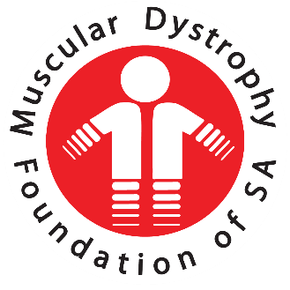
  - Annual Report 2018
  - Muscular Dystrophy Foundation of South Africa, KZN Branch

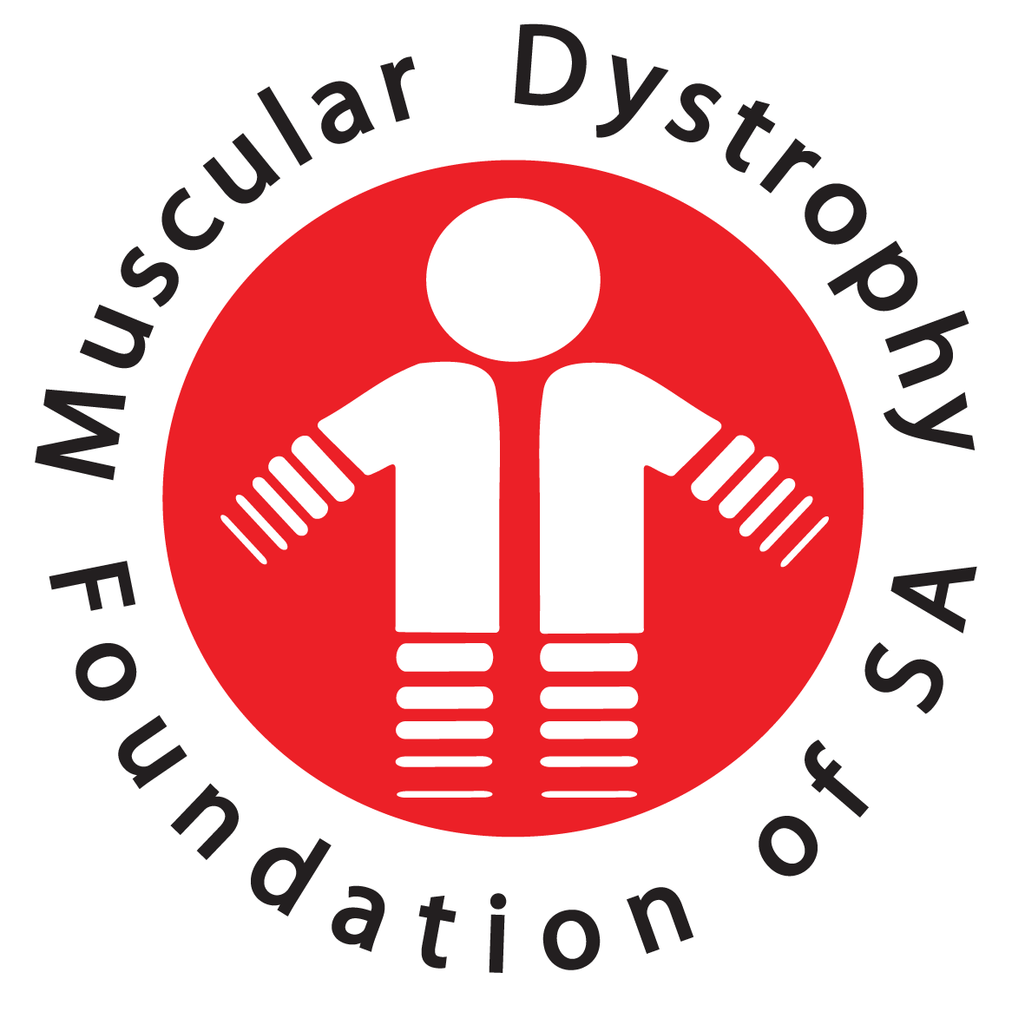

CHAIRMAN KZN REPORT 2017
A warm welcome to everyone present to our MDF –KZN Annual General Meeting 2018.
It is my privilege to present my report to you which came with lots of challenges and achievements.
This year has been a very rewarding year for the KZN branch and I am proud to say that our office has progressed in leaps and bounds with pursuing and implementing some of our strategic goals.
This came with its unique challenge and as ever the biggest of all of them is funding, and I must say to our staff, committee members, you have given us your energy and passion to push forward, to achieve the reality of tight budgets and the risk of unsuccessful fundraising.
I am very proud to be associated and be part of this dynamic, motivated and passionate team and want to acknowledge and thank the executive committee in assisting me and the Foundation to achieve these goals.
Our goals for the year 2018
1. Our database has increased from 728 to 733 (5) signed memberships to date.
2. Fundraising to increase our cash flow from avenues which our executive committee and staff members have tried to implement. Examples are collection tins for till points at major stores, sale of water, recipe books, golf day, and appeals to corporate companies for donations to purchase motorized wheelchairs, sale of stickers for Casual Day and the participation in the liters for education program. I appeal to all to join the Foundation on a volunteer basis creating a cash flow to assist us to pay a stipend to our volunteers.
3. Awareness. As for the information on MDF, we have printed a number of brochures previously which we have distributed to parents, patient hospitals and doctors surgeries. Thanks to a donor, we were able to develop a parent’s guide that will be available for the next financial year. WE ALSO NEED TO LOOK AT CREATING GROUPS FOR SUPPORT AND CARE, CHILDREN, PARENTS AND ADULTS.
4. Support to our members has been tremendous this year where members of the public, Lotto and corporates have donated manual and motorized wheelchairs and also small donations to our office. We have donated this equipment to various members as needed and also assisted with other needs such as batteries and cushions.
TO OUR DEDICATED STAFF AND EXECUTIVE MEMBERS, YOUR CONTRIBUTUIONS HAVE MADE THE KZN BRANCH ACHIEVE OUR GOALS FOR 2018 AND WE HOPE WE CAN DO MORE WITH ASSISTANCE FROM VARIOUS VOLUNTEERS IN 2019.
Noel Pillay
Chairman – KZN Branch

